CMPE-235 Mobile Software Design

Mobile App Design



**Submitted to**

Prof. Jerry Gao

**Date of Submission**

Dec 03, 2017

**Submitted by:**

**Project Group 7**

|  |  |
| --- | --- |
| Pooja Shah | 010828311 |
| Mohamad Shafaat Ali Khan | 011480430 |
| Nisha Raghu | 011442834 |
| Sindhya Kumari Nellaiappan | 011504987 |
| Sneha Kasetty | 010128950 |

**Table of Contents**

**Abstract** **2**

**1. Introduction** **3**

**2. Project Requirements** **3**

2.1 Users 3

2.2 Context and environment for to access the mobile app 3

2.3 Major tasks supported by the mobile app 3

**3. Major tasks supported by the mobile app** **4**

**4. Architecture** **5**

4.1 Infrastructure Diagram 6

4.2 Use Case 7

4.2 Use Case Description 10

4.3 Functional Flow Diagram 18

4.4 Data Design 19

**5. UI Specification** **20**

5.1 Design 20

5.1 UI Design Specification 20

5.3 Screen Navigation 21

5.4 App Structure 22

**6. Technology Selection and Usage** **23**

**7. Implementation** **24**

7.1 UI Screens 24

7.2 Server Implementation 44

**9. Demo** **54**

**11. References** **54**

## Abstract

Using energy services such as electricity, hydro, gas can prove to be expensive if used extensively. In order to reduce costs in your business when it comes to energy, there are a variety of different factors you need to consider. By assessing the needs of your employees and your customers when it comes to providing quality and standard energy, you’ll be able to make a plan that helps you cut costs where you need it the most. There are many ways which can help provide a better energy solution in low cost. Some of these include establishing good energy efficient practices such as switching off equipment when not in use, getting energy audit done, replacing existing bulbs with Compact Fluorescent Lamp and LED lights as they consume much lesser energy and also last longer. We can also invest in energy efficient devices that that reduce the cost. We have provided an energy savings platform where the consumer can choose and schedule between many energy services to be installed in their organization which would help them conserve energy and reduce cost over time.

# 

# 

# 

## 1. Introduction

In this technologically driven world where everything is just a click away, it is important for customers to have easy access to IoT systems and energy solutions. Energy solutions help reduce the overall effective cost of the energy services used. Users require a platform where energy solutions can be provided for their buildings/homes offices etc. JustLight (JLT) R2 Energy Service platform provides various Energy Solutions to customers. Customers can select the services and they can pay for the rented services. In this document, we are providing the details of the Energy Service Rental mobile application for admin, customer and vendors.

## 2. Project Requirements

### 2.1 Users

JLT application can be used by 3 users: Admin, Customers and Energy Resource Vendors. Admin, Customer and Vendor can register themselves in the system by selecting the appropriate type of account. Admin, Customer and Vendor can log into the system and see the dedicated view of dashboard as per their account type.

### 2.2 Context and environment for to access the mobile app

The user must have the mobile application in their Android or iOS device installed.The consumers can use the mobile app to rent various energy solutions such as Solar Energy, fixing Smart Lighting in the house (LED lighting fixture products), providing window films to reduce the heat and maintain temperature within a facility or provide UV protection, HVAC (Heating, ventilation and Air conditioning) etc. By opting for Energy resources to power up facilities, the consumers save about 30% on energy cost savings.

### 2.3 Major tasks supported by the mobile app

Main task of the application is to provide Energy Resource Services on rent and details of Return on Investment (ROI). Moreover, this application will also provide the functionalities such as Multi Tenancy, digital payment, analytics, etc. Following are the detailed overview of the tasks that each user can perform.

**Customer:** Customers can register themselves in the system and by default, they will get limited functionality of the system. Customers will be able to upgrade their account type to VIP in order to get the additional features and full support from mobile application. Customers can mainly view and rent one or more services available in the system and add them in the cart. They should be able to filter available services depending on the service name, price or favorite vendors. Customer can anytime go back to the cart and review their orders. They can pay for their selected services using credit card. Customers also have an opportunity to pay the rent in full amount or in installments. The installments can be paid over a period of 3, 6 or 12 months. Once they set their payment, customer can schedule an appointment with the vendor for installing those services. Customer can view the usage report generated by a system which can provide the customer the details of energy consumption and performance details. If customer decides to upgrade their account to VIP, they get few more advantages such as, discount on the services, free installation and easy scheduling of an appointment.

**Admin:** The admin user can register in the system by signing up. They can view registered Energy Resource Vendors as well as all the services available in the system. Admin user can also view the registered customers. In case of any glitches in the system, the Administrator is contacted.

**Energy Resource Vendor:** Vendors should be able to register themselves in the system using Sign up. They can manage their services by adding, removing or updating them. Vendors can also view appointments scheduled by customers in order to provide the installation services to them. Vendors can additionally cancel the scheduled appointments if the service is not available.

## 3. Major tasks supported by the mobile app

Main task of the application is to provide Energy Resource Services on rent and details of Return on Investment (ROI). Moreover, this application will also provide the functionalities such as Multi Tenancy, digital payment, analytics, etc. Following are the detailed overview of the tasks that each user can perform.

**Customer:** Customers can register themselves in the system and by default, they will get limited functionality of the system. Customers will be able to upgrade their account type to VIP in order to get the additional features and full support from mobile application. Customers can mainly view and rent one or more services available in the system and add them in the cart. They should be able to filter available services depending on the service name, price or favorite vendors. Customer can anytime go back to the cart and review their orders. They can pay for their selected services using credit card or PayPal. Customers also have an opportunity to pay the rent in full amount or in installments. Once they set their payment, customer can schedule an appointment with the vendor for installing those services. Customer can view the usage report generated by a system which can provide a customer the details of energy consumption and performance details. If customer decides to upgrade their account to VIP, they get few more advantages such as, discount on the services, free installation, easy scheduling an appointment and so on.

**Admin:** The admin user can register in the system by signing up. They can view registered Energy Resource Vendors as well as all the services available in the system. Admin user can also view the registered customers.

**Energy Resource Vendor:** Vendors should be able to register themselves in the system using Sign up. They can manage their services by adding, removing or updating them. Vendors can also view appointments scheduled by customers in order to provide the installation services to them.

## 4. Architecture

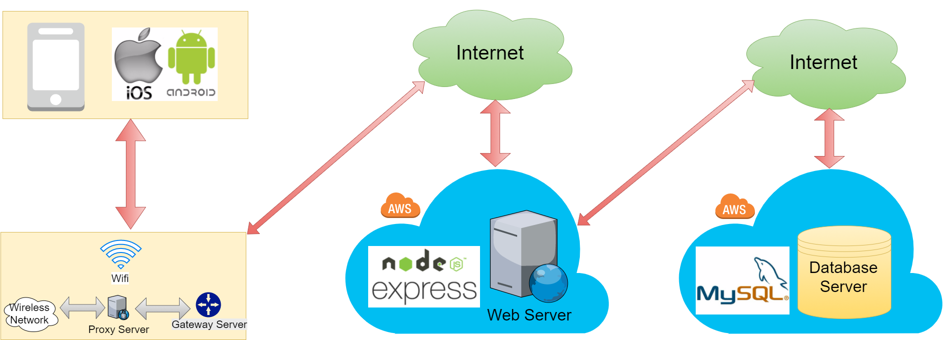

Fig 1. Architecture Diagram

Fig 1 shows the architecture diagram of the green building solution system. It consist of the following components

* Mobile application
* Backend web server
* Database

**Mobile application**: The mobile application is a hybrid app which can run on Android and iOS platforms. The ends users of mobile application are Admin, Customer and Vendor. The mobile application consist of Admin Dashboard, Customer Dashboard, Vendor Dashboard and various pages for other services.

**Backend web server**: The backend web server connects mobile application to database. It is done via REST API calls. The backend is responsible to redirect HTTP requests. The backend also takes care of the authentication of the users.

**Database**: The database used for this system is NoSQL. The database is MongoDB where different collections are stored. The database is connected to the backend using mongoose library. It helps us to provide CRUD operations in the database

### 4.1 Infrastructure Diagram

Fig 2 shows the infrastructure diagram of this green building solution system. This system has Heroku based web server and SQL database. There are 3 users vendor, customer and admin who will have the mobile app having respective view. Mobile devices can use the wifi or mobile data network to establish the connection with the cloud server. REST endpoints are installed on nodeJS server using HTTP protocols. Customer’s mobile app can communicate with vendor for any scheduling services and vendor can communicate with admin for any of the services to be added or removed.

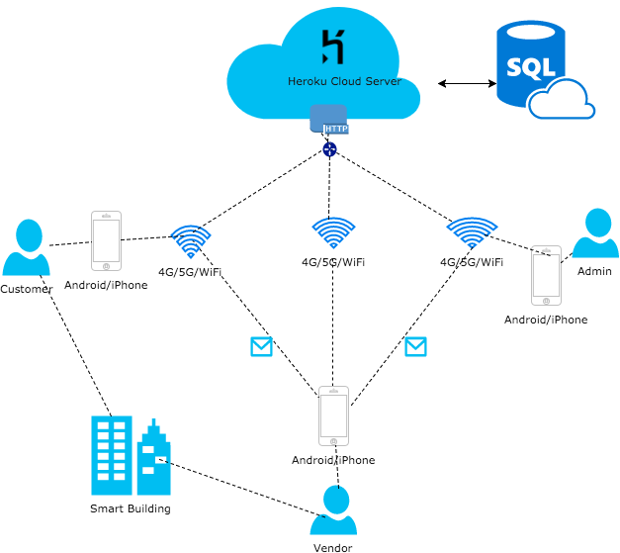

Fig 2. Infrastructure Diagram

### 4.2 Use Case

The energy services app consists of three actors: Admin, Energy service providers, Customers. The use case diagrams of all the three actors are shown below.

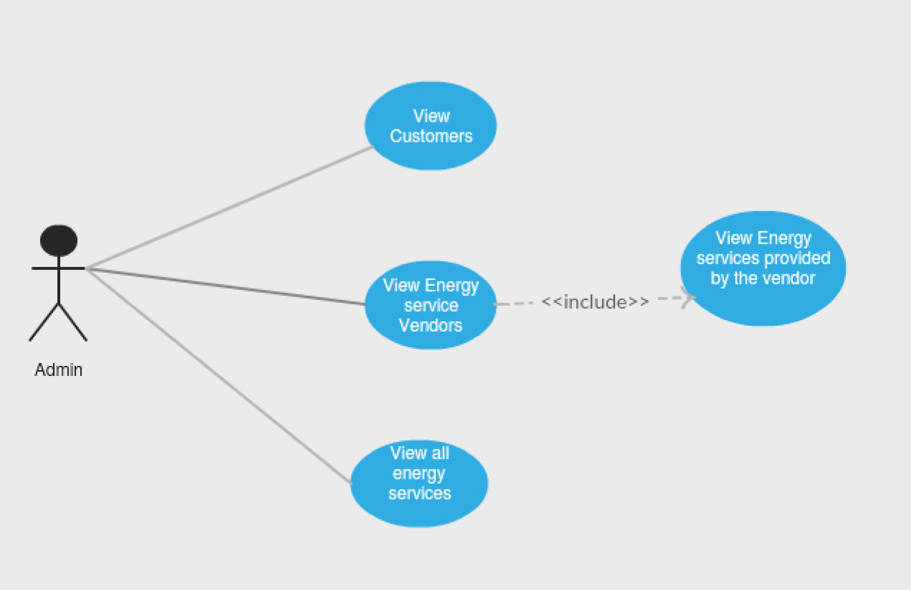

Fig 3. Usecase diagram - Admin

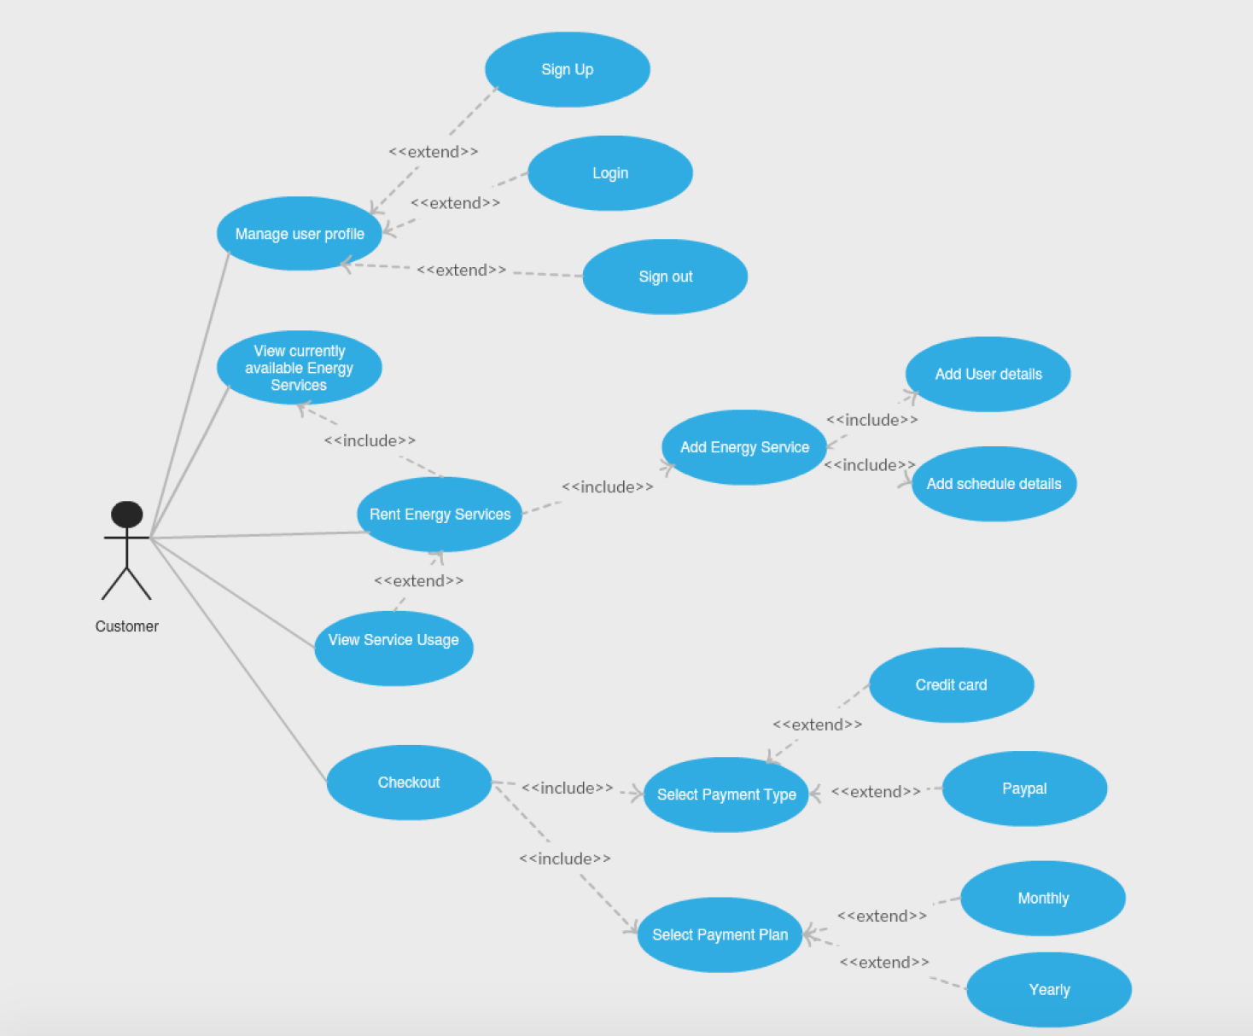

Fig 4. Usecase diagram - Customer

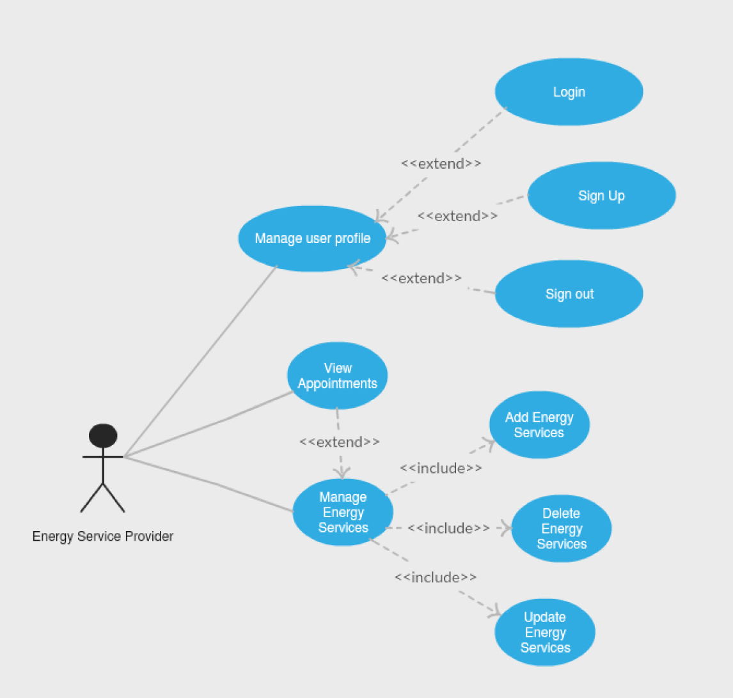

Fig 5. Usecase diagram - Vendor

### 4.2 Use Case Description

|  |  |
| --- | --- |
| ***Use Case*** | **Manage User Profile** |
| ***Description*** | Manage user profile details |
| ***Actors*** | Customer, Energy Service Provider |
| ***Pre-conditions*** | The application is installed in mobile |
| ***Post-condition*** | Profile information is created or updated based on the user action |
| ***Basic Flow*** | 1. Open Energy Service mobile application  2. Click on Login or Signup on the main screen |

|  |  |
| --- | --- |
| ***Use Case*** | **Sign-up** |
| ***Description*** | To create an account in the Energy Services app. |
| ***Actors*** | Customer, Energy Service Provider |
| ***Pre-conditions*** | The user does not have an existing account in Energy Services app. |
| ***Post-condition*** | A new account is created for the user |
| ***Basic Flow*** | 1. Open the application  2. Click on “Sign-up” button in the main menu  3. Fill the user details  4. Click on the “Sign up” button |
| ***Alternate Flow*** | If the sign up screen displays error, the user should try to modify the details and click on “Sign up” again. |

|  |  |
| --- | --- |
| ***Use Case*** | **Sign-in** |
| ***Description*** | To Login to an existing account. |
| ***Actors*** | Customer, Energy service provider |
| ***Pre-conditions*** | The user has an existing account in the Energy services app. |
| ***Post-condition*** | The user has logged in successfully |
| ***Basic Flow*** | 1. Open the app  2. Click on “Sign in” button  3. Enter the credentials and login |
| ***Alternate Flow*** | If the app fails to login, the user should try to modify the credentials and try to login again |

|  |  |
| --- | --- |
| ***Use Case*** | **Sign-out** |
| ***Description*** | To sign out from the application |
| ***Actors*** | Customer, Energy Service Provider |
| ***Pre-conditions*** | The user is signed in the application |
| ***Post-condition*** | The user signs out of the app successfully |
| ***Basic Flow*** | 1. Open the app  2. Click Sign out in the main menu |
| ***Alternate Flow*** | If sign –out fails, the user should try to re-sign-out again. |

|  |  |
| --- | --- |
| ***Use Case*** | **View Customers** |
| ***Description*** | To View the customers registered in the application |
| ***Actors*** | Admin |
| ***Pre-conditions*** | The admin must be logged in the application |
| ***Post-condition*** | The admin views the list of registered customers |
| ***Basic Flow*** | 1. Click “View Customers” in the main menu  2. The list of customers is displayed |

|  |  |
| --- | --- |
| ***Use Case*** | **View Energy Service Providers** |
| ***Description*** | To view the list of registered energy service providers |
| ***Actors*** | Admin |
| ***Pre-conditions*** | The admin must be logged in the application |
| ***Post-condition*** | The admin views the list of registered energy service providers |
| ***Basic Flow*** | 1. Click “View Energy Service Providers” in the main menu  2. The list of energy service providers is displayed |

|  |  |
| --- | --- |
| ***Use Case*** | **View Energy Services** |
| ***Description*** | To view the list of all energy services provided by the vendors |
| ***Actors*** | Admin |
| ***Pre-conditions*** | The admin must be logged in the application |
| ***Post-condition*** | The admin views the list of all energy services |
| ***Basic Flow*** | 1. Click “View Energy Services” in the main menu  2. The list of energy services is displayed |

|  |  |
| --- | --- |
| ***Use Case*** | **View all Energy Services** |
| ***Description*** | To view the energy services currently provided by the vendors |
| ***Actors*** | Customer |
| ***Pre-conditions*** | The customer must be logged in the application |
| ***Post-condition*** | The customer views the list of energy services provided by all vendors |
| ***Basic Flow*** | 1. Click “View Energy Services” in the main menu  2. The list of energy services is displayed  3. Select an energy service to view the details of each service |
| ***Alternate Flow*** | If there are no energy services provided currently, the list is empty.  Click “back” button to go to the main menu. |

|  |  |
| --- | --- |
| ***Use Case*** | **Rent Energy Services** |
| ***Description*** | To rent the energy service provided by the vendors |
| ***Actors*** | Customer |
| ***Pre-conditions*** | The customer must be logged in the application |
| ***Post-condition*** | The customer has rented an energy service successfully |
| ***Basic Flow*** | 1. Click “Rent Energy Services” in the main menu  2. The list of energy services is displayed  3. Select an energy service and click “Add” to add a service  4. Enter the user and schedule details and click on “submit”.  5. The service is added to the cart |
| ***Alternate Flow*** | If there are no energy services provided currently, the list is empty.  Click “back” button to go to the main menu. |

|  |  |
| --- | --- |
| ***Use Case*** | **View service usage** |
| ***Description*** | To view the service usage of the rented services |
| ***Actors*** | Customer |
| ***Pre-conditions*** | The customer must be logged in the application |
| ***Post-condition*** | The service usage of the service is displayed successfully. |
| ***Basic Flow*** | 1. Click “View Service Usage” in the main menu  2. The service usage of all the rented services are displayed. |
| ***Alternate Flow*** | If there are no services rented by the customer the list is empty.  Click “back” button to go to the main menu. |

|  |  |
| --- | --- |
| ***Use Case*** | **Checkout** |
| ***Description*** | To pay for the rented service |
| ***Actors*** | Customer |
| ***Pre-conditions*** | The customer must be logged in the application |
| ***Post-condition*** | The customer has paid for the rented services successfully |
| ***Basic Flow*** | 1. Click “Cart” in the main menu  2. The list of rented energy services is displayed with the price  3. Confirm the list and click on “Checkout” to checkout  4. Select the payment method and enter the payment details  5. Click on pay to pay for the rented services |
| ***Alternate Flow*** | If there are no rented services currently, the cart list is empty.  If the payment details are not valid then the payment is not successful. Try again with correct payment details. |

|  |  |
| --- | --- |
| ***Use Case*** | **Add Energy services** |
| ***Description*** | To add a new energy service |
| ***Actors*** | Energy Service Provider |
| ***Pre-conditions*** | The vendor must be logged in the application |
| ***Post-condition*** | The vendor has added the energy service successfully |
| ***Basic Flow*** | 1. Click “Add Energy Service” in the main menu  2. Enter the details of the service and click on “submit” button |
| ***Alternate Flow*** | If the app fails to add service, re-enter the service details and submit. |

|  |  |
| --- | --- |
| ***Use Case*** | **Delete Energy services** |
| ***Description*** | To delete energy service |
| ***Actors*** | Energy Service Provider |
| ***Pre-conditions*** | The vendor must be logged in the application. |
| ***Post-condition*** | The energy service is deleted successfully |
| ***Basic Flow*** | 1. Click “Delete Energy Service” in the main menu  2. Select the energy service and click on “Delete” to delete the service |

|  |  |
| --- | --- |
| ***Use Case*** | **Update Energy services** |
| ***Description*** | To update energy service |
| ***Actors*** | Energy Service Provider |
| ***Pre-conditions*** | The vendor must be logged in the application. |
| ***Post-condition*** | The energy service is updated successfully |
| ***Basic Flow*** | 1. Click “Edit Energy Service” in the main menu  2. Select the energy service and click on “Edit”  3. Edit the details of the service and click “submit” |
| ***Alternate Flow*** | If the details are not updated, re-enter the details and submit again. |

|  |  |
| --- | --- |
| ***Use Case*** | **View Appointments** |
| ***Description*** | To view the list of schedules from the customers to install the services. |
| ***Actors*** | Energy Service Provider |
| ***Pre-conditions*** | The vendor must be logged in the application. |
| ***Post-condition*** | The list of appointments is displayed successfully |
| ***Basic Flow*** | 1. Click “View appointments” in the main menu  2. The list of appointments are displayed |
| ***Alternate Flow*** | If there are no appointments, the list is empty.  Click “back” button to go to the main menu. |

### 4.3 Functional Flow Diagram

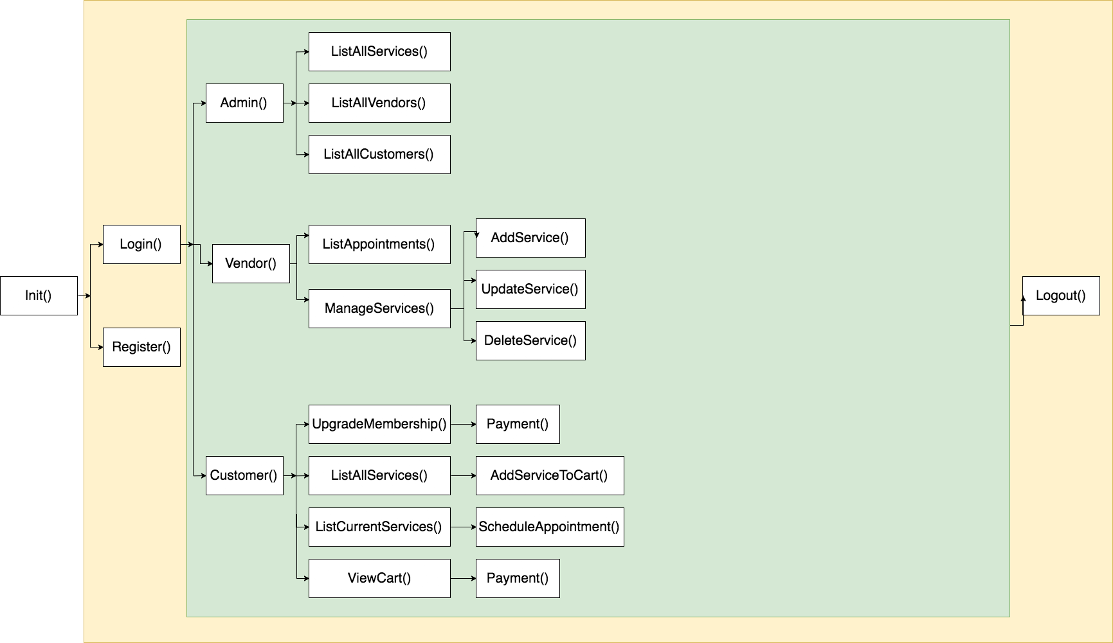Fig 6. Functional Flow Diagram

#### 

#### 

#### 

#### 4.4 Data Design

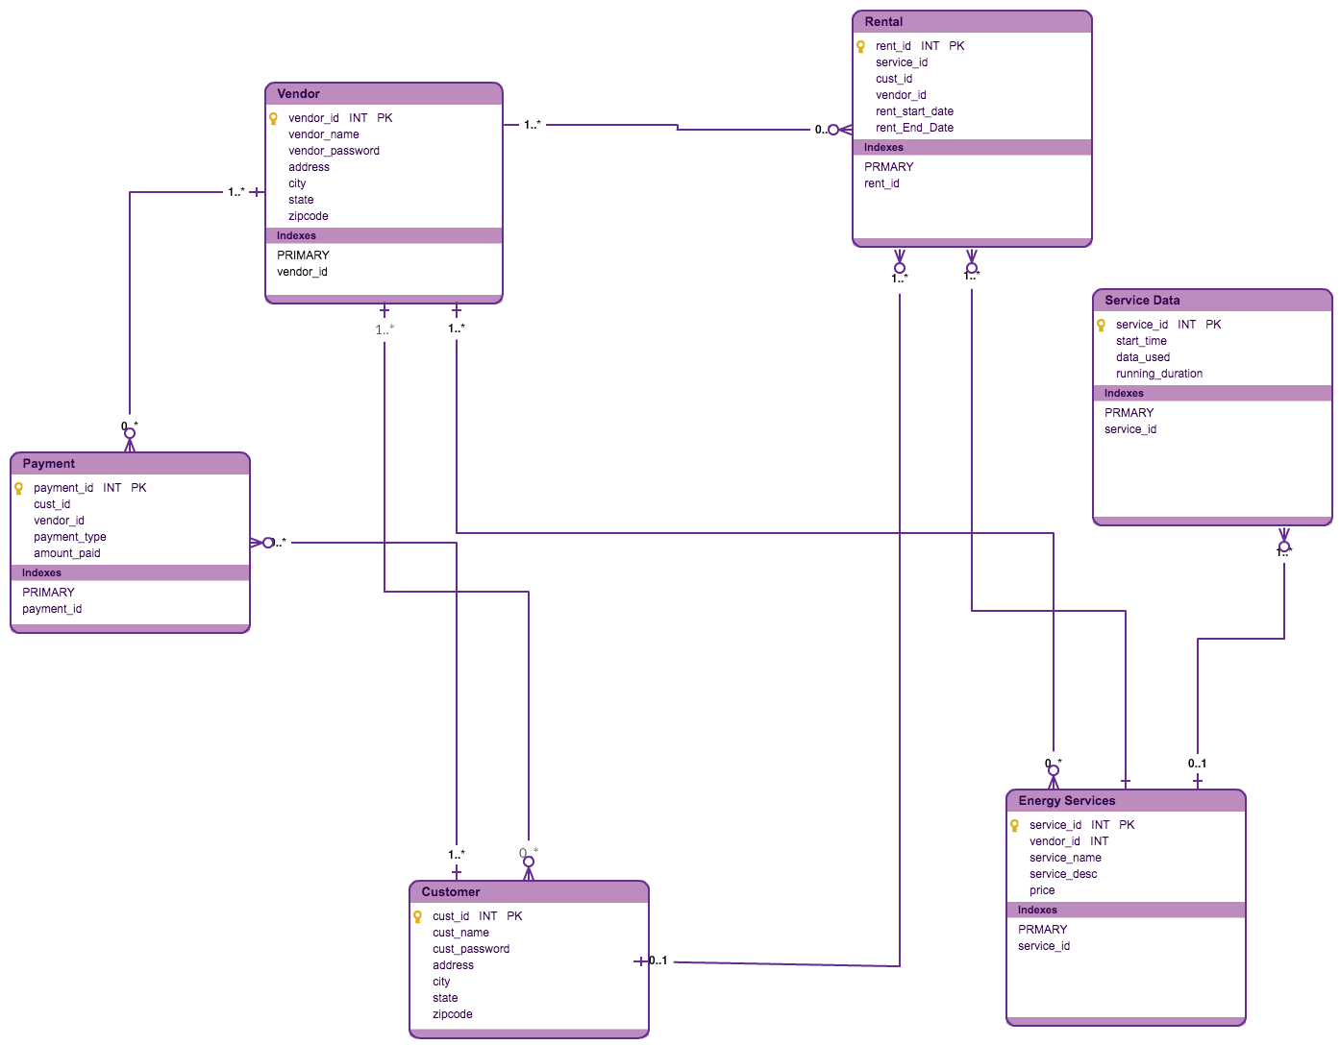

Fig 7. Data Design

## 5. UI Specification

### 5.1 Design

Our application aims at creating a user friendly mobile web based application. It allows the user to access the platform on web as well as various other mobile devices. The app GUI design is mentioned in section [10]. We have followed a simple UI style design to serve the main purpose of each screen as mentioned below.

* Primary purpose of the screen: Each screen would serve its primary purpose without having any ambiguity.
* Simply to use: The users can interact with each page without spending too much time and effort.
* Simple text for the user to read and understand.
* Error messages such as User input errors or permission errors are displayed to the user.
* Confirmation messages are displayed when the user adds an energy source and pays for the energy sources.
* Gestures to scroll, swipe, dismiss, tilt, pinch, rotate, drag etc. are provided for easy use.
* Textboxes have auto-complete and suggestions feature.

### 5.1 UI Design Specification

JLT application consists of the following UI design specifications:

1. **Color Selection**: For our mobile app, we have used consistent colors throughout our app. We have used the same color for the button’s which compliments the respective pages.
2. **Page Templates:** The application is developed using Reactive-Native. We have used the RkStyleSheet to style our individual pages. We have two supported UI themes in our application. One is the “Light theme” and the other the “Dark theme”. Based on the user’s preference they can change the theme of the app in the theme settings page.
3. **Supporting Gestures:** The application supports various gestures which includes but is not restricted to – touch, press, tap, drag, flick, slide, pinch, rotate and swipe.
4. **Make Use of the Small Screen:** While designing our pages we have kept in mind the size of the screen and designed the screen appropriately. For page where user needs to enter form details we have kept a place holder so that it is easier for user to enter the details. We have made the font size big which will be easy for the user to read.
5. **Quick Access to Tasks:** We have provided all the main functionalities of the User in the Dashboard. The user can easily navigate to the required page from the dashboard. All the end pages also have a navigation to the dashboard which makes it convenient for the user to access the different pages.
6. **Clear Page Name:** We have named each page with a title, so this make it easier for user to know which page they are currently looking at.

### 5.3 Screen Navigation

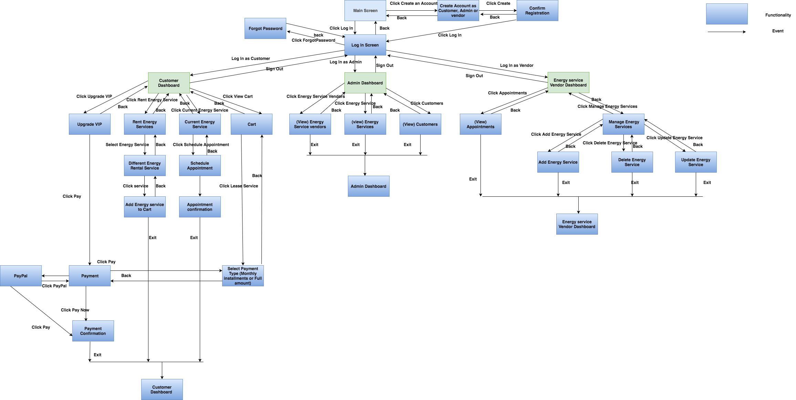

Fig 8. Navigation Diagram

### 5.4 App Structure

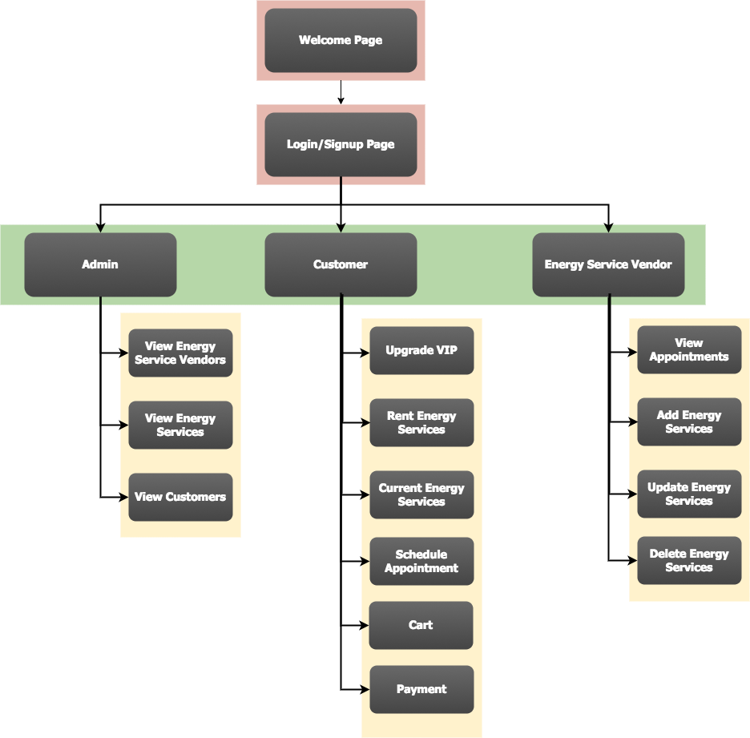

Fig 9. App Structure Diagram

## 6. Technology Selection and Usage

The following technologies are proposed for the system:-

**Frontend UI:** ReactJS Native, Bootstrap

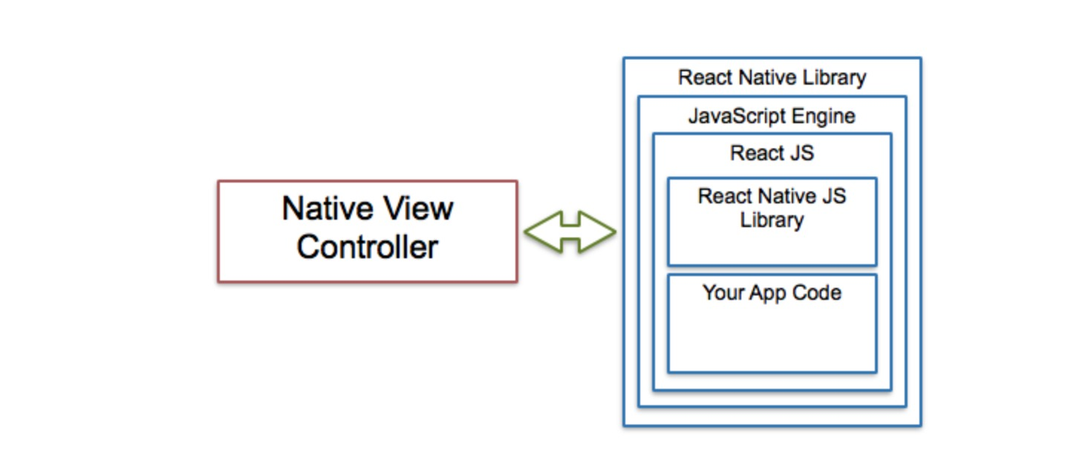

Fig 10. ReactNative Implementation

**Backend Web Services:** Node.js and Express.js

**Central Data Repository:** MySql

**Load Balancer:** Nginx Server

**Cloud Technologies for Deployment:** AWS

## 

## 7. Implementation

The deliverable of JustLight Green building solutions is a Mobile App for Customer, Vendor and Admin. JustLight Mobile application is made for both andoid and iOS devices.

### 7.1 UI Screens

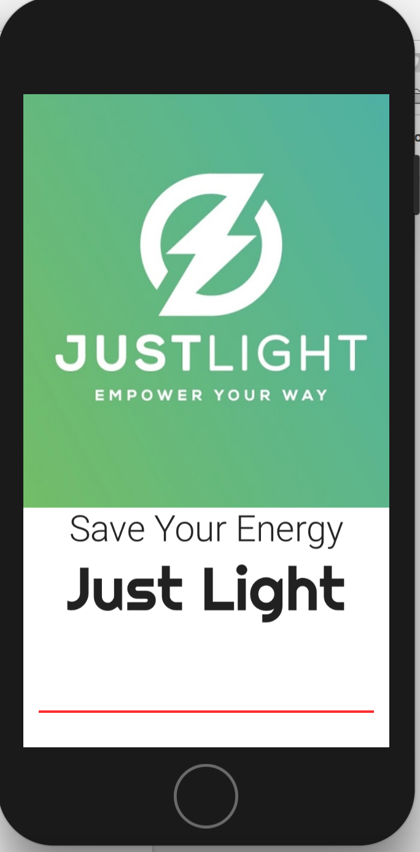

Fig 11. Splash Screen

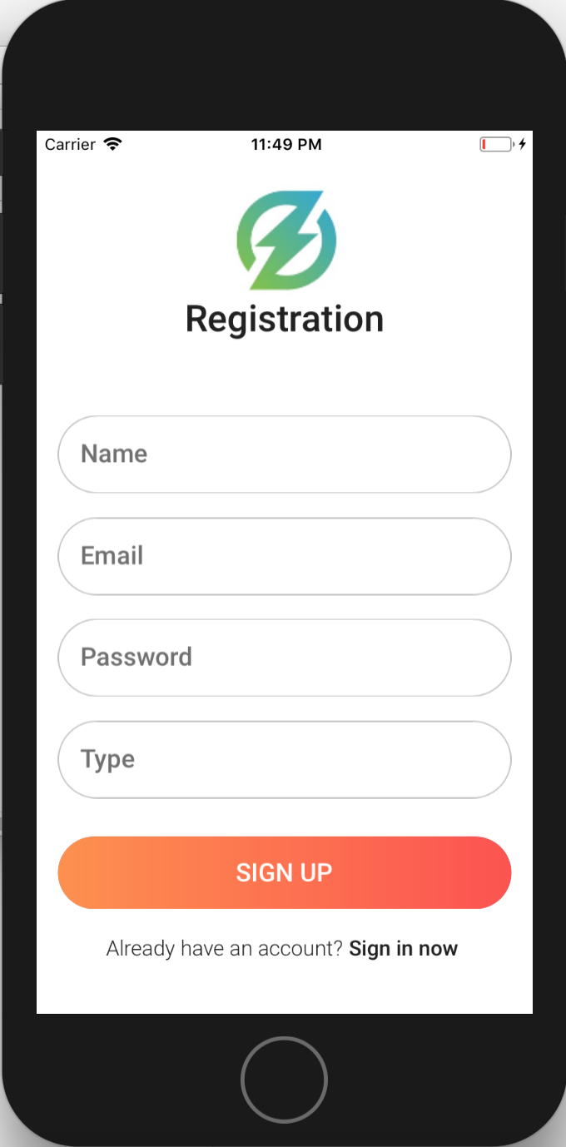

Fig 12. Signup Page

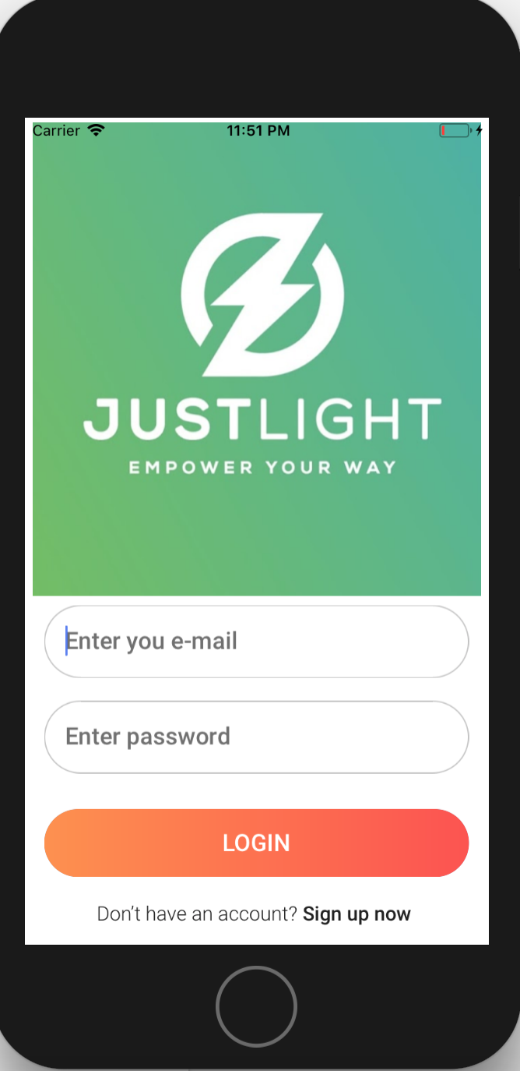

Fig 13. Sign in Page

CUSTOMER DASHBOARD

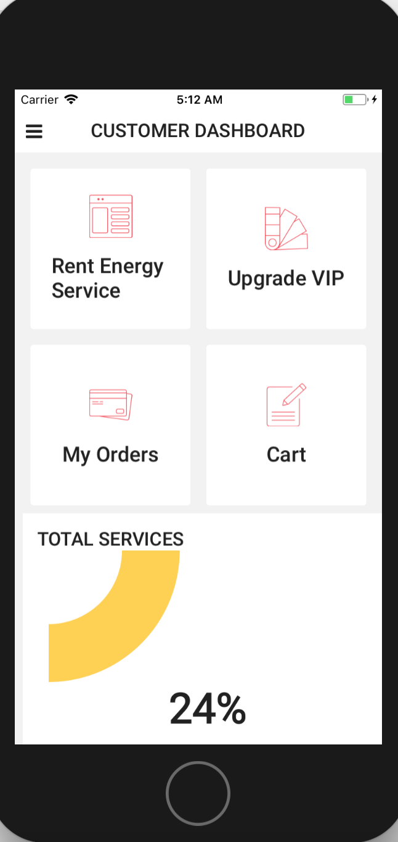

Fig 14. Customer Dashboard

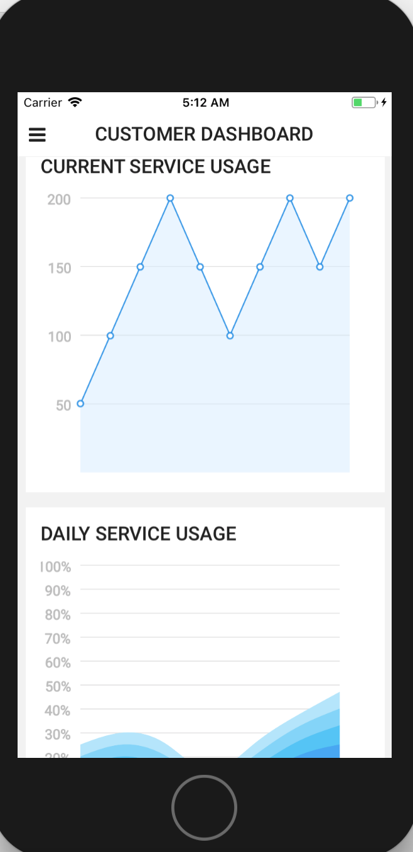

Fig 15. Customer Dashboard

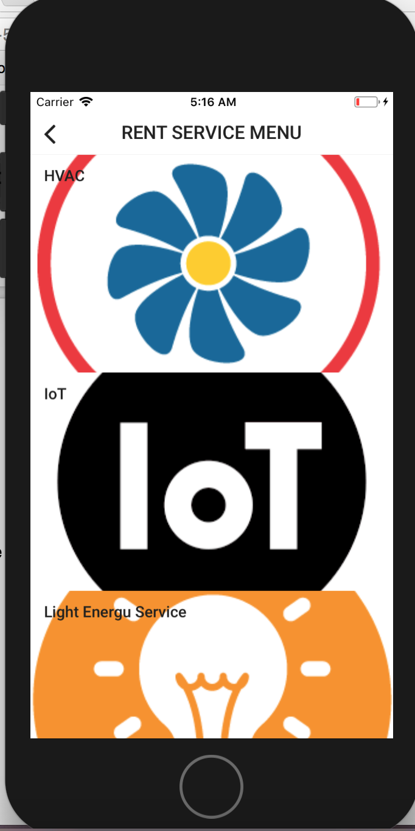

Fig 16. Rent Energy Services

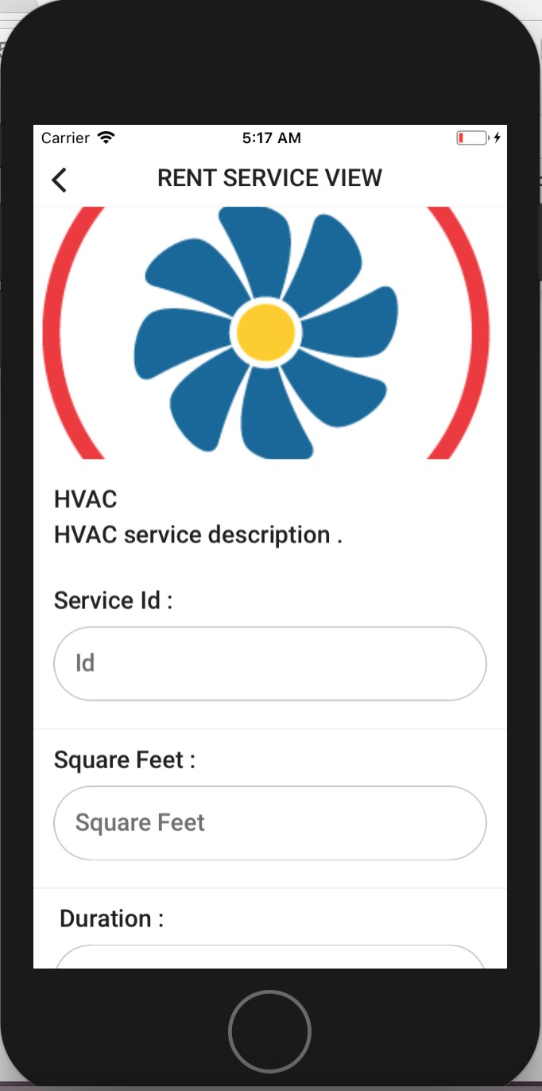

Fig 17. Rent Energy Services Details

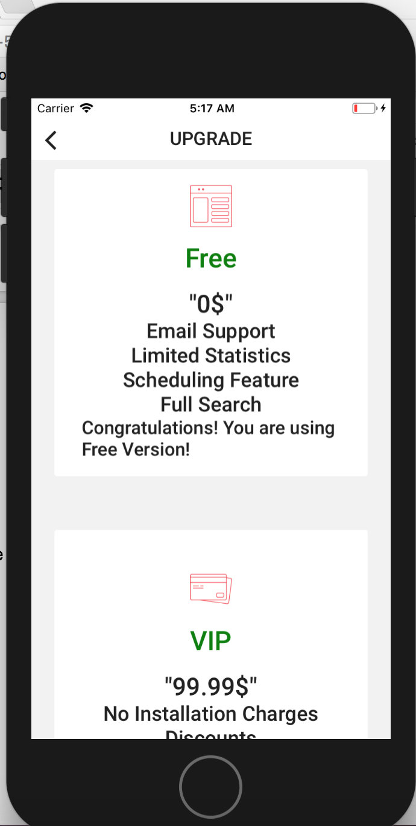

Fig 18. Upgrade

### 

Fig 19. My Cart

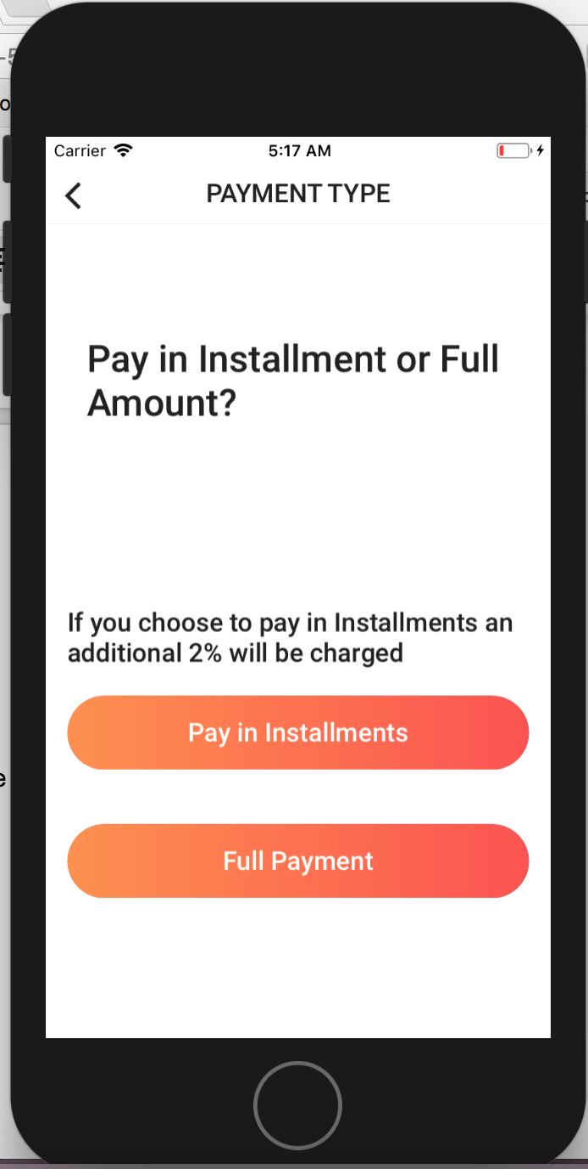

Fig 20. Payment Options

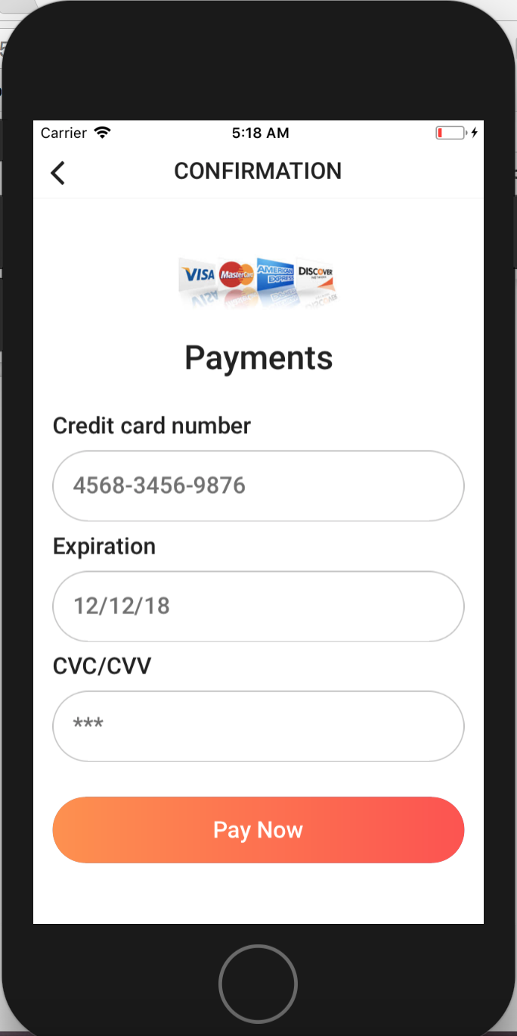

Fig 21. Payment

### 

Fig 22. Payment Confirmation

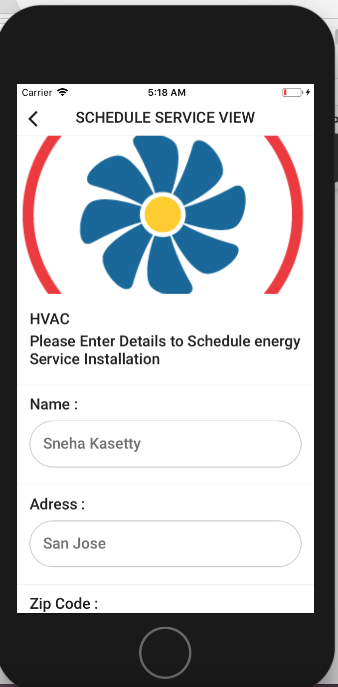

Fig 23. Schedule Appointment for installation

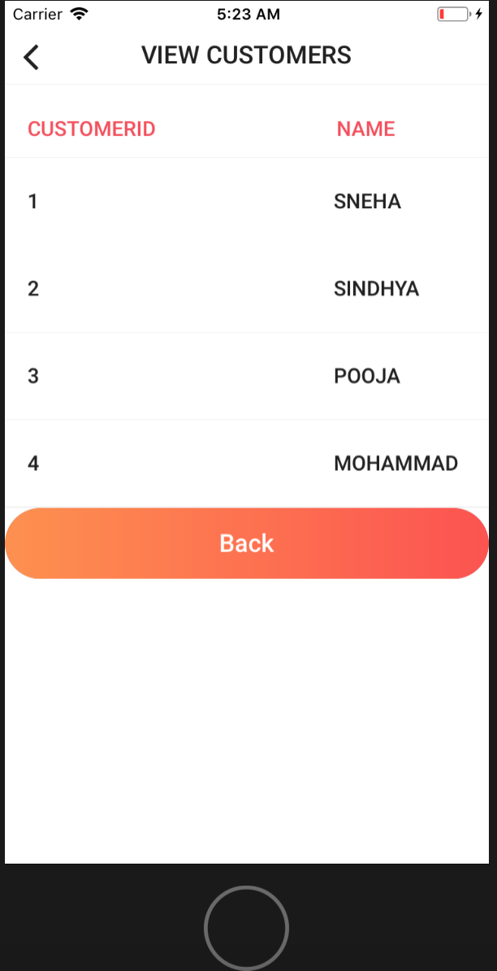

Fig 24. View Customers

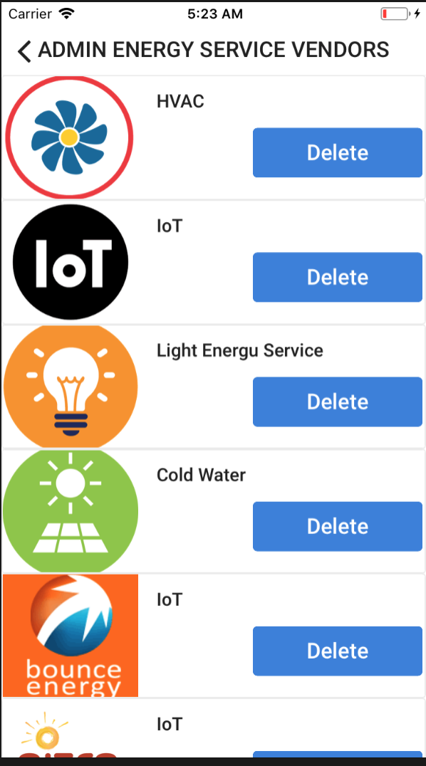

Fig 25. Energy Service Vendors

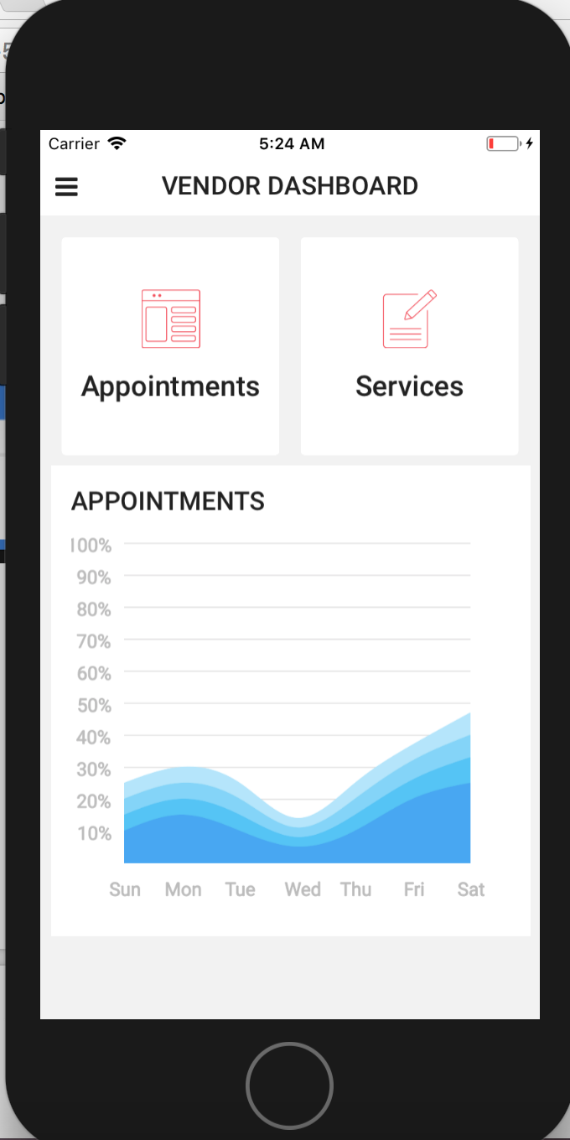

Fig 26. Vendor Dashboard

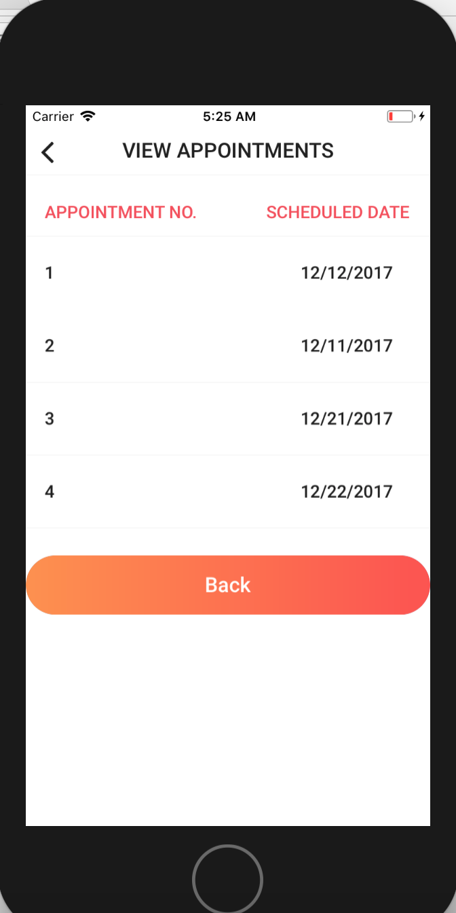

Fig 27. View Appointments

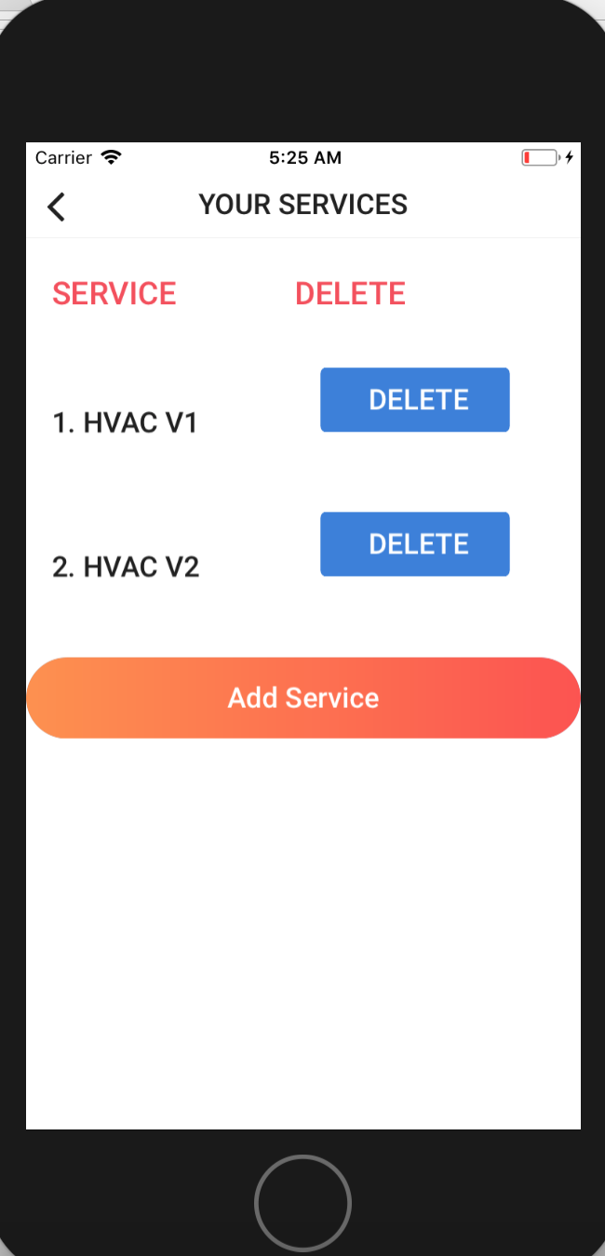

Fig 28. Manage Services

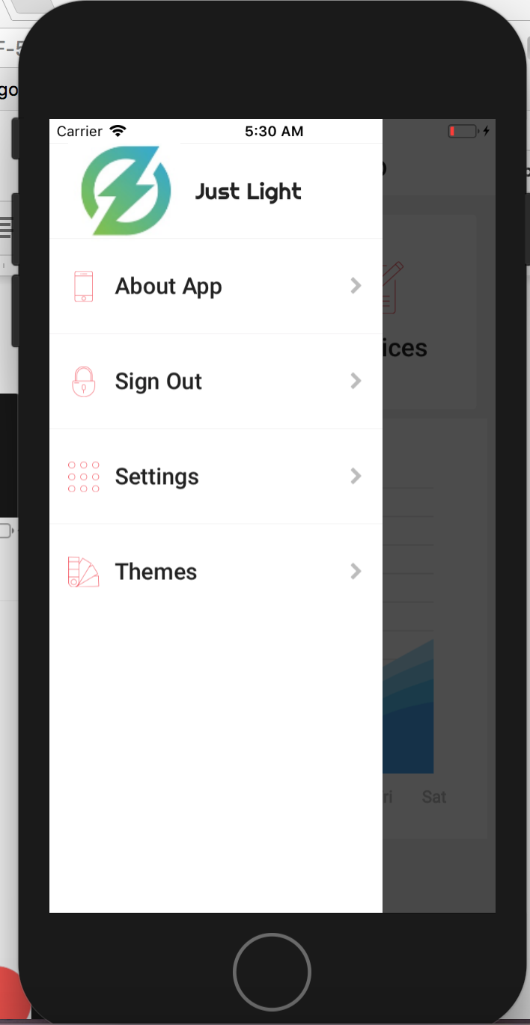

Fig 29. Side Menu for easy access

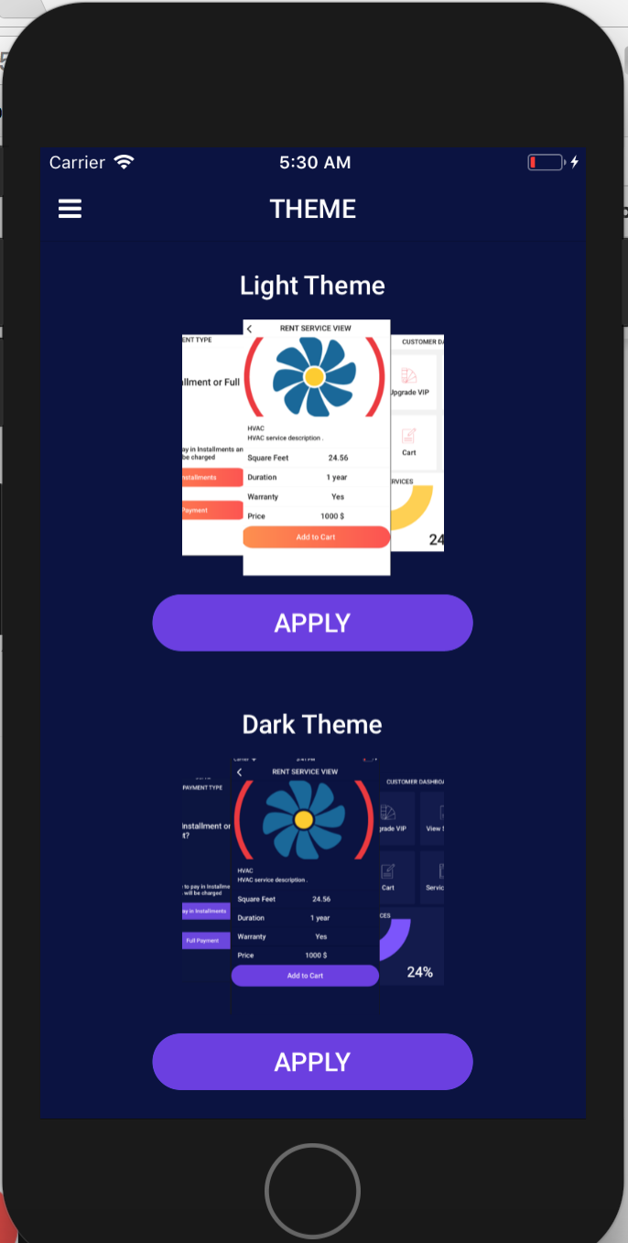

Fig 30. Theme Selection

### 7.2 Server Implementation

The backend server is written using Nodejs and Expressjs. The database used is MongoDB. The backend is deployed on Heroku cloud. MongoDB is is deployed on MLab. The server is implemented using CICD. Whenever the changes are made in the code, it is send to github. Heroku is configured with Github and for every push it automatically builds the code.

The backend web server uses following libraries

* Bcryptjs- Used to encrypt the password in database
* Body-parser- to read JSON body
* Express- To create API routes
* Jsonwebtoken- for generating tokens and authentication
* Mongoose- to connect to database
* Mongoose-unique- to enter unique entities in mongodb

Screen shots:

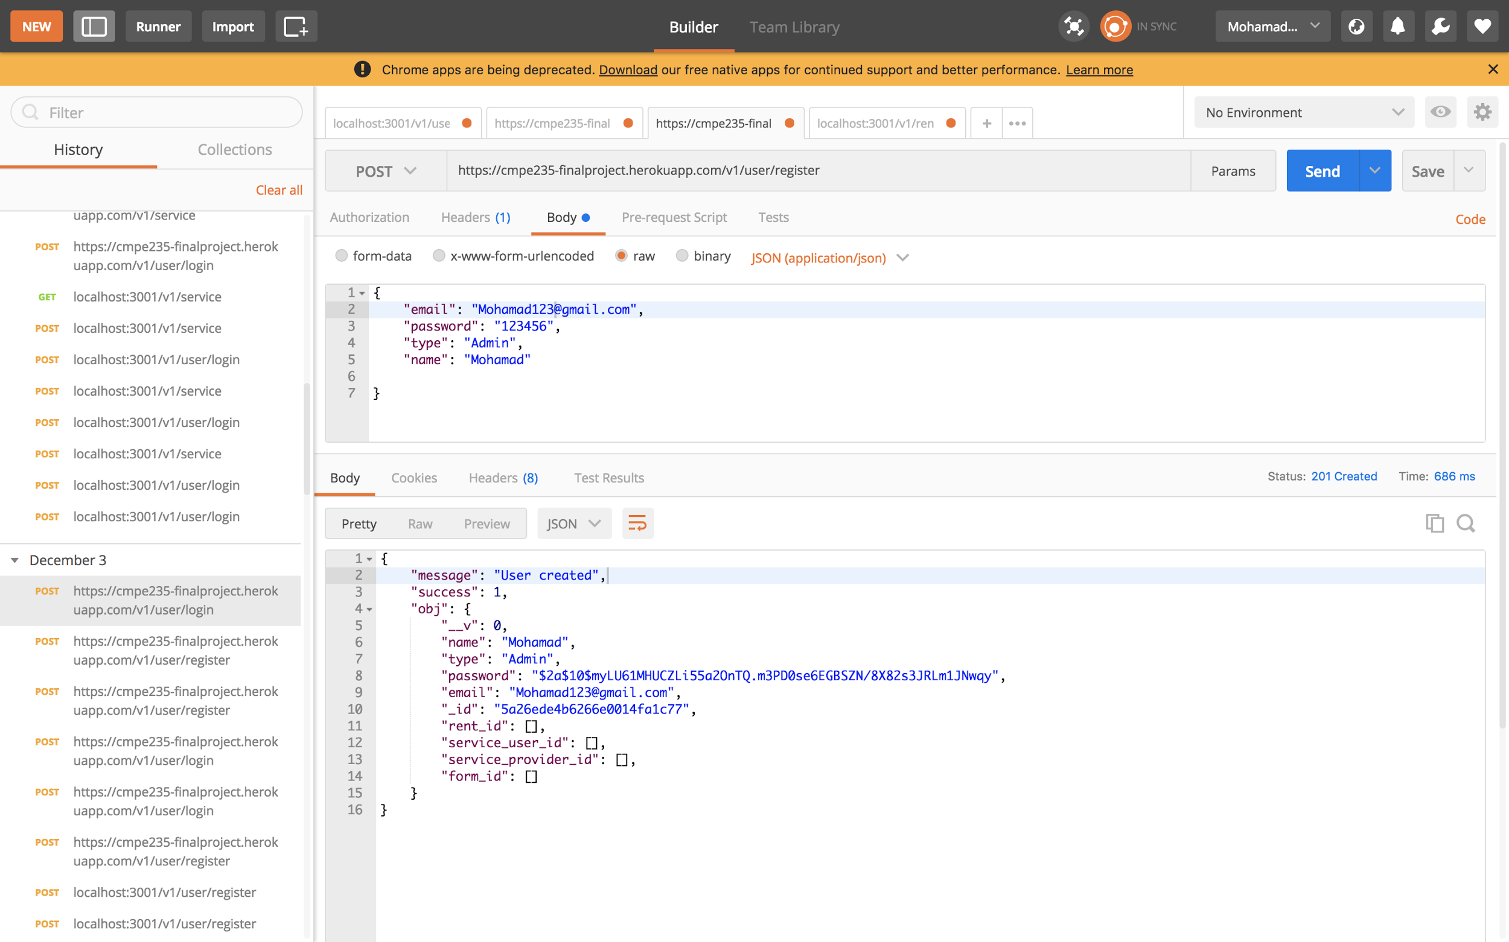

Fig 31. REST API calls using POSTMAN

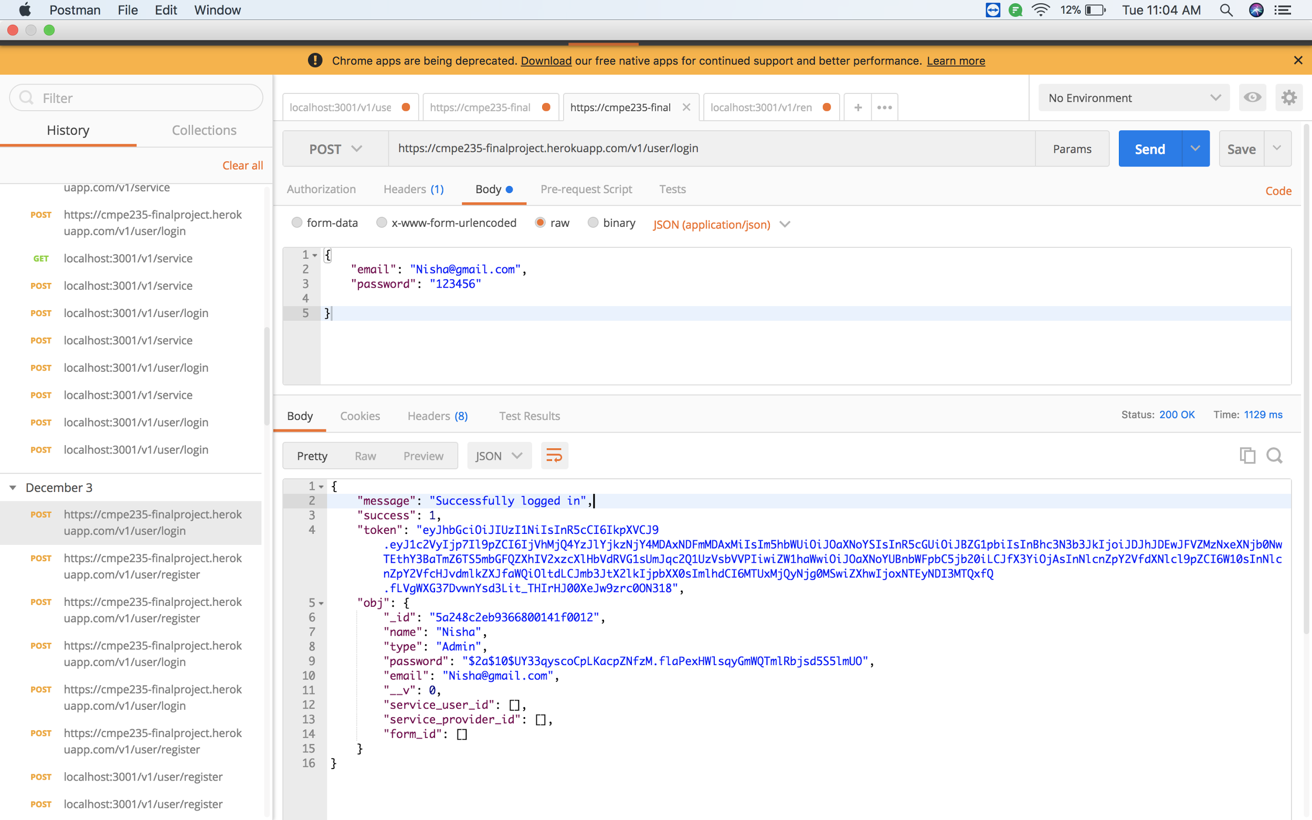

Fig 32. REST API calls using POSTMAN

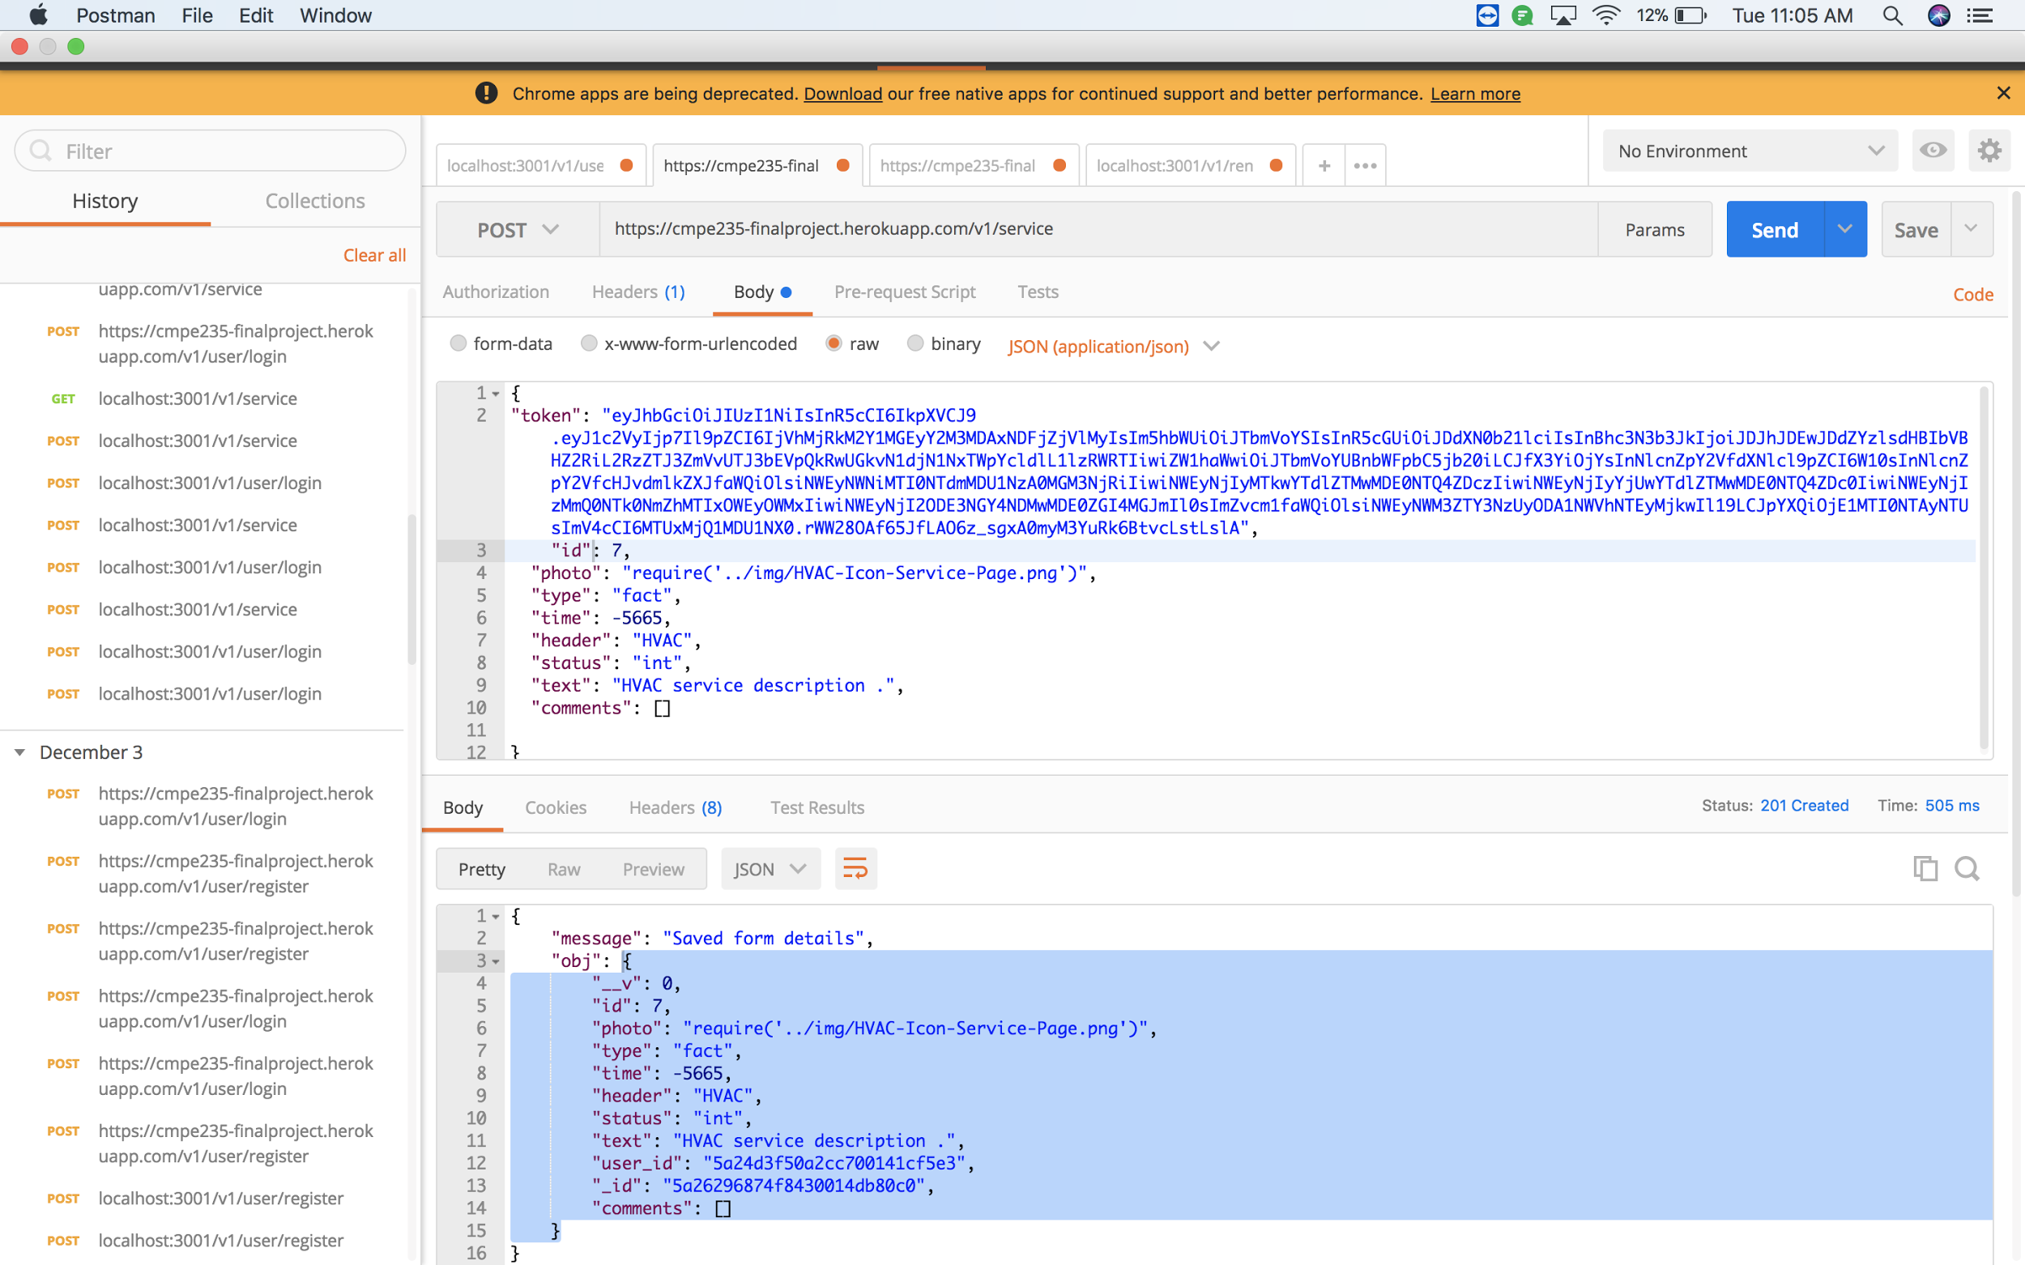

Fig 33. REST API calls using POSTMAN

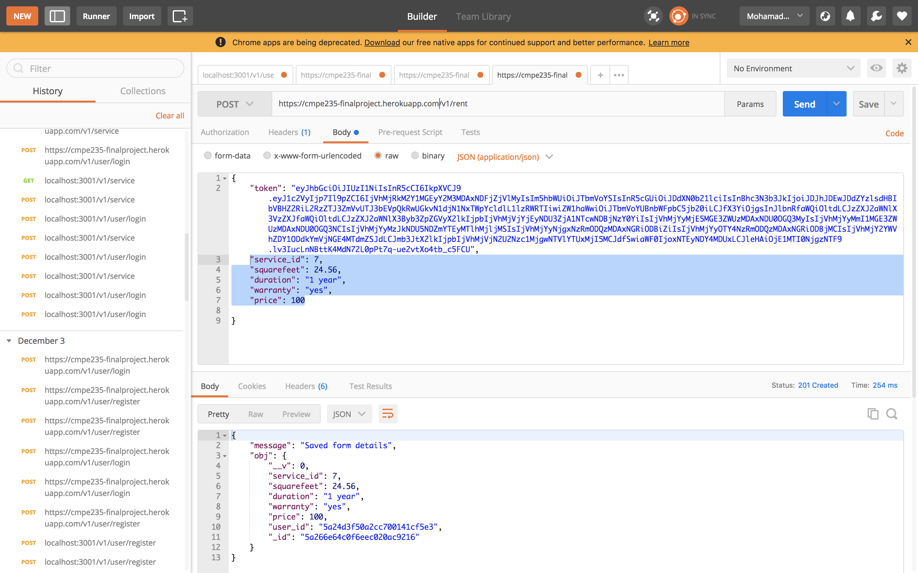

Fig 34. REST API calls using POSTMAN

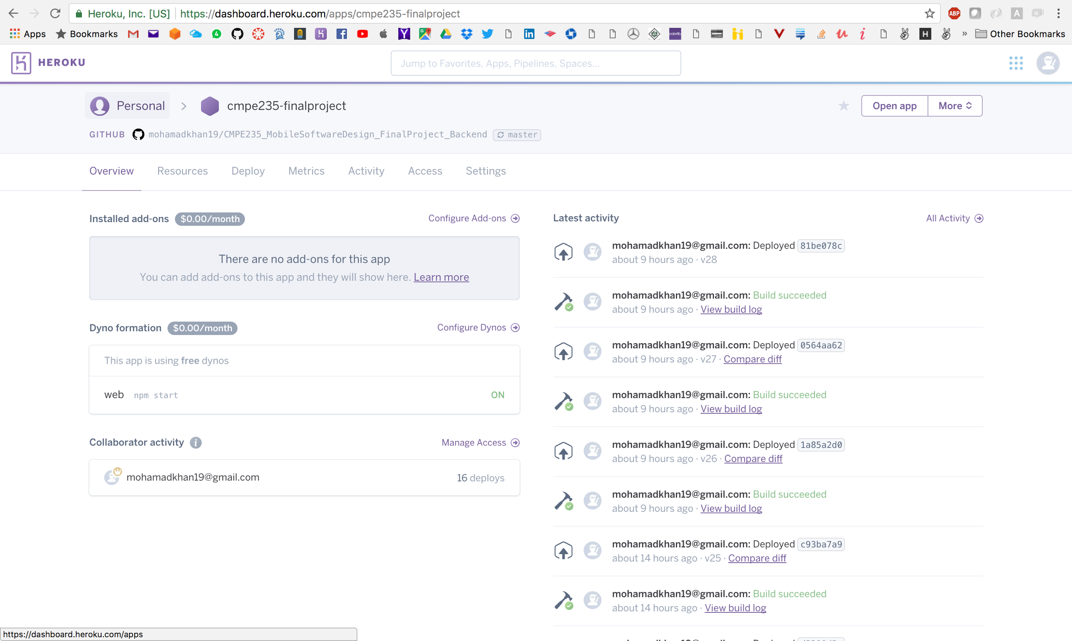

Fig 35. Heroku Cloud for deployment

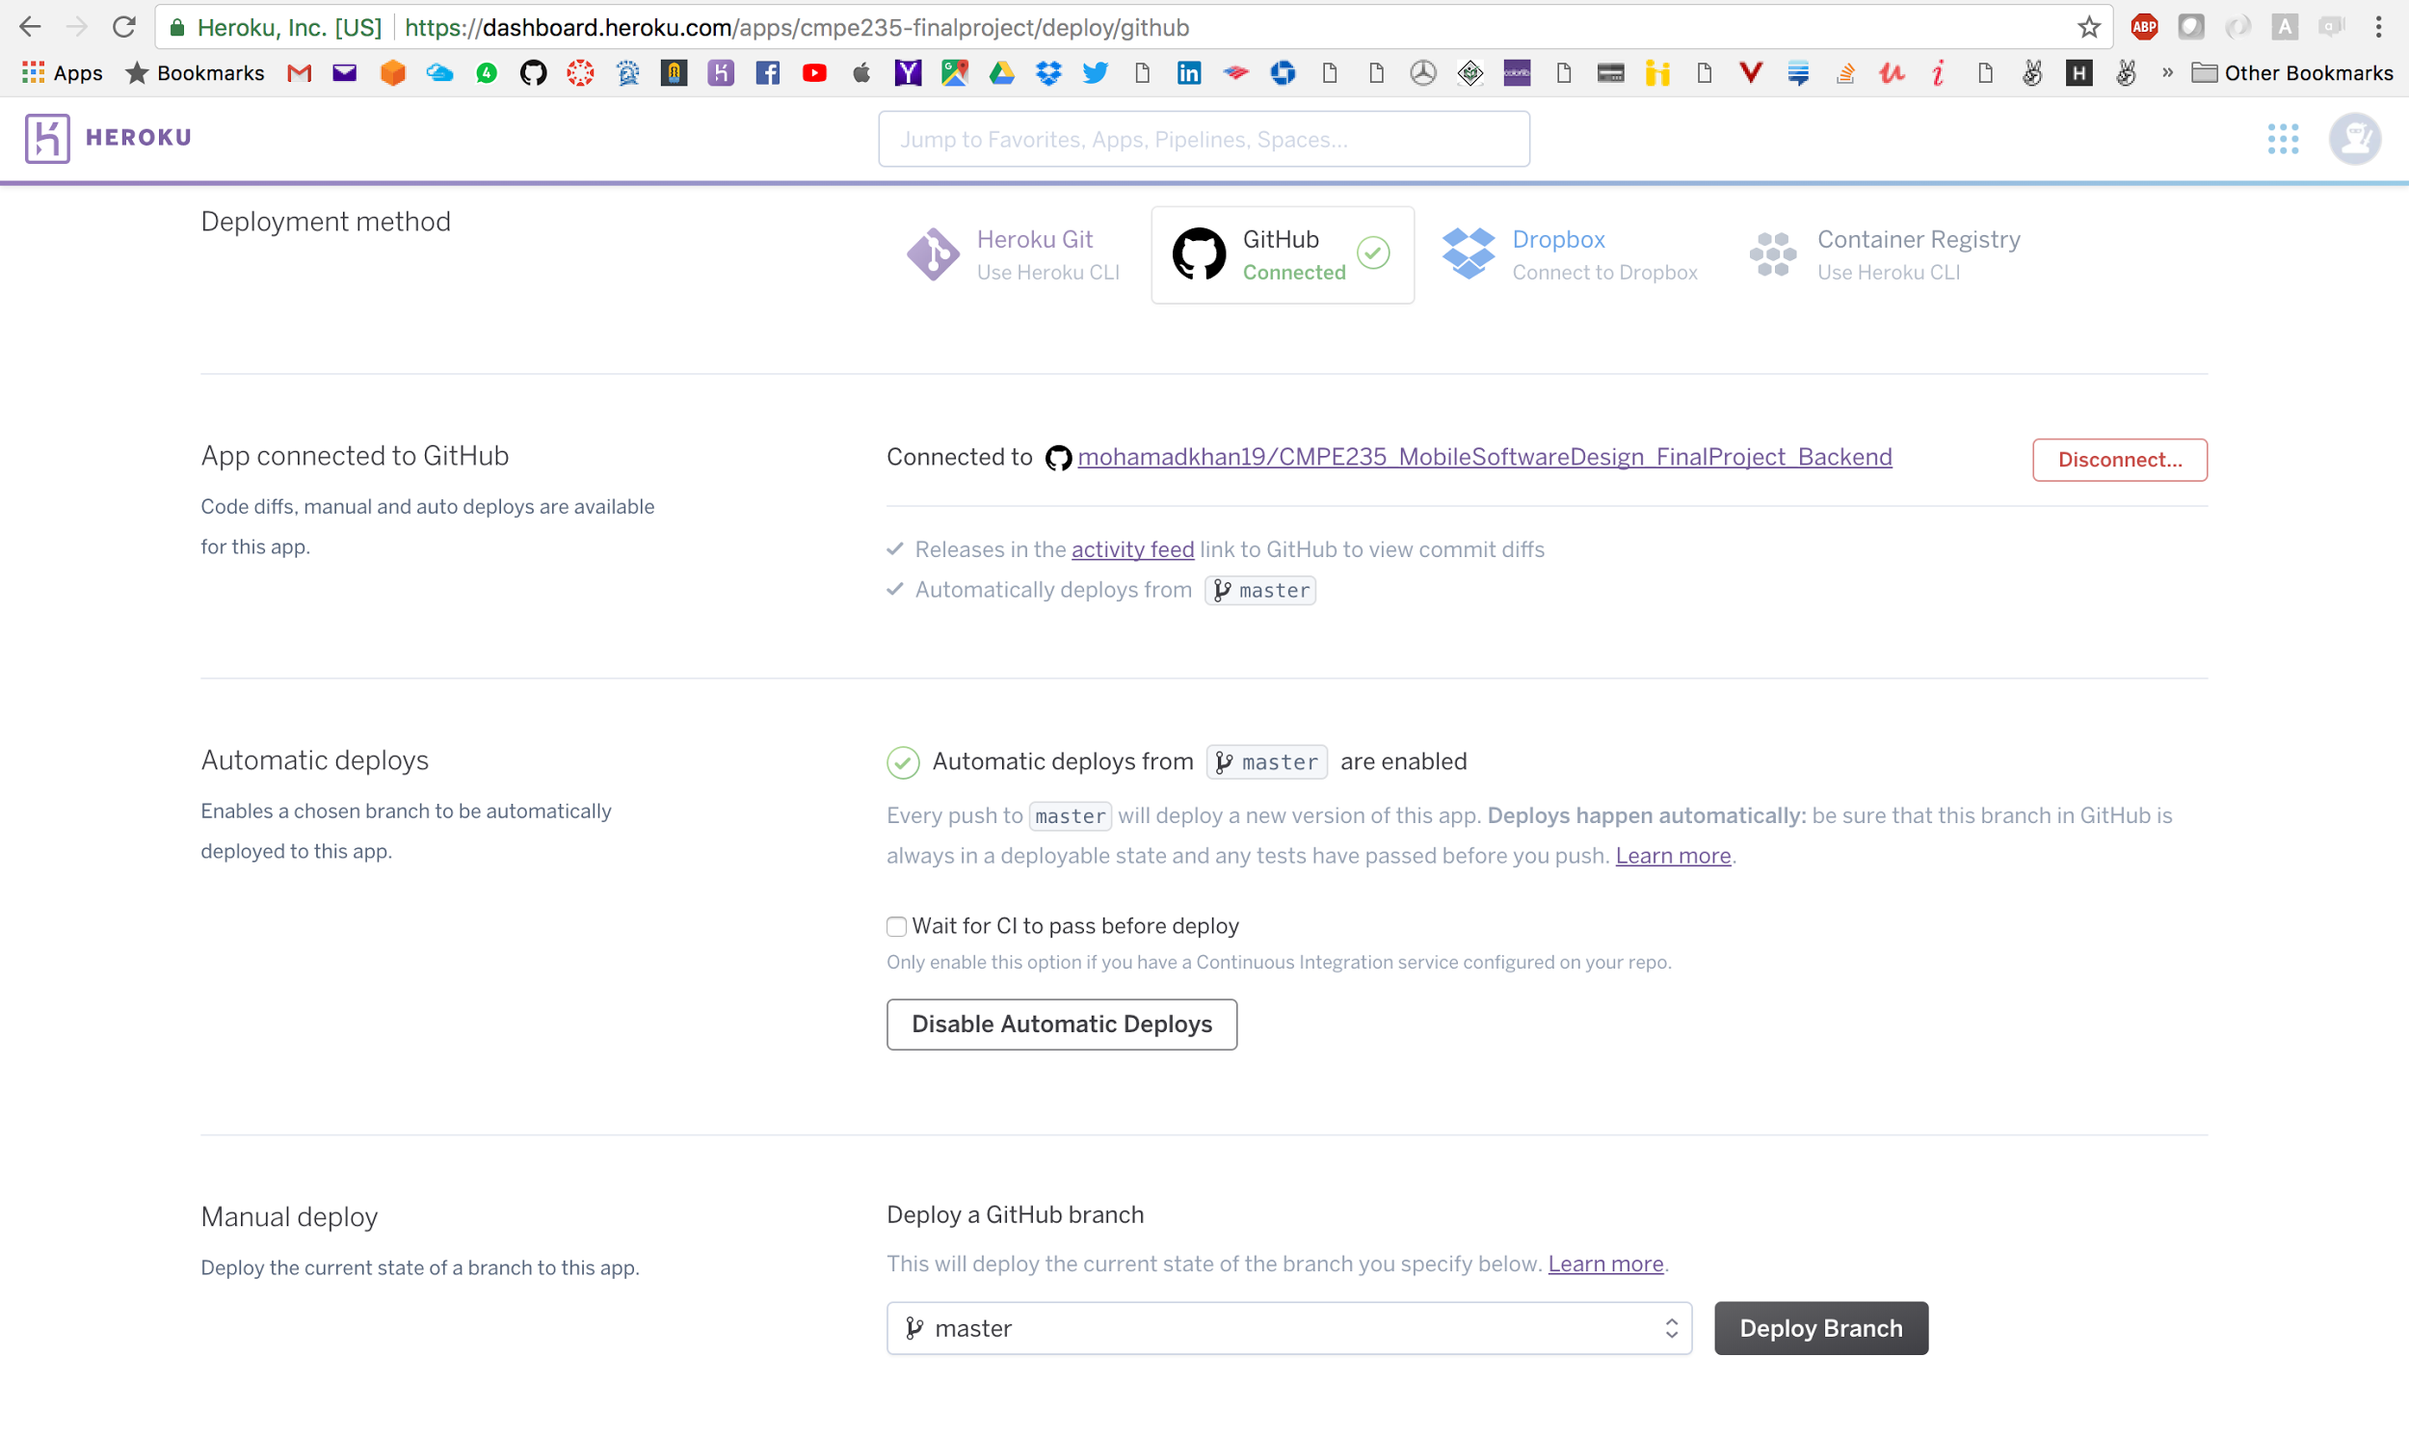

Fig 36. Heroku integration with Github

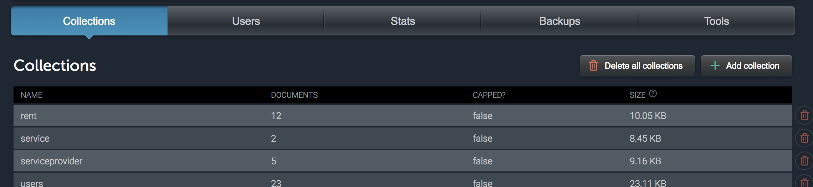

Fig 37. Mongodb Database

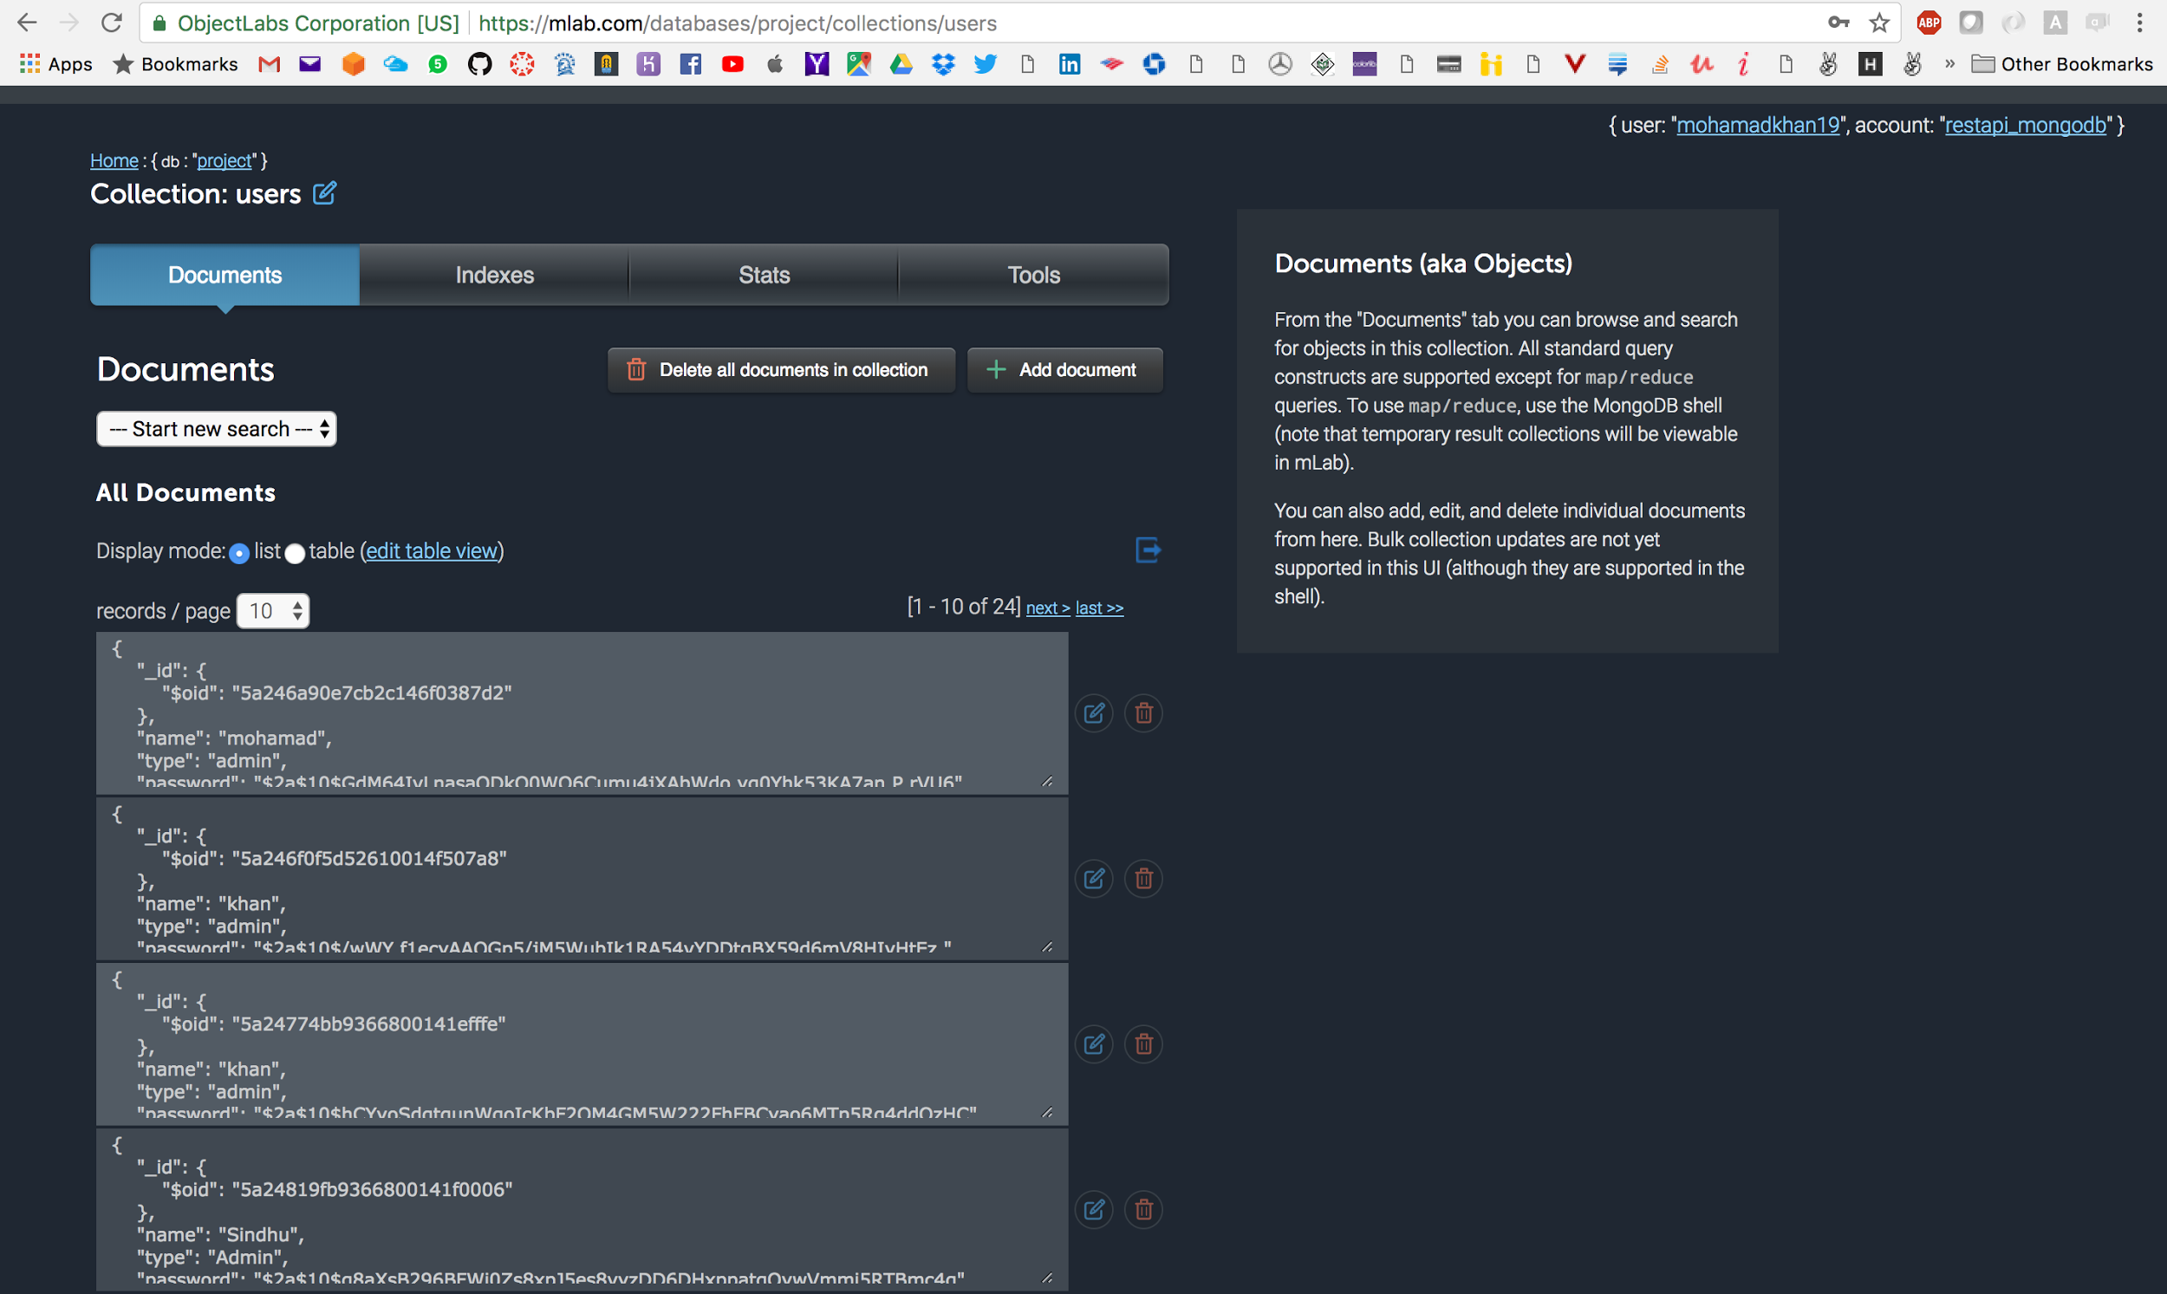

Fig 38.: User collection

|  |  |
| --- | --- |
| **Action** | User Login |
| **URI** | https://cmpe235-finalproject.herokuapp.com/v1/user/login |
| **HTTP Method** | POST |
| **Parameter** | N/A |
| **Headers** | |  | | --- | | {  Content-Type: "application/json, charset=utf-8",  } | |
| **Body** | |  | | --- | | {  email: <email>,  password: <password>  } | |
| **Return success (data + statusCode)** | HTTP/1.1 200 OK   |  | | --- | |  | |
| **Return failure (statusCode)** | HTTP/1.1 500 Server Error -- Fail to fetch data |

|  |  |
| --- | --- |
| **Action** | User Register |
| **URI** | https://cmpe235-finalproject.herokuapp.com/v1/user/register |
| **HTTP Method** | POST |
| **Parameter** | N/A |
| **Headers** | |  | | --- | | {  Content-Type: "application/json, charset=utf-8",  } | |
| **Body** | |  | | --- | | {  email: <email>,  password: <password>,  type: <type>,  name: <name>,  } | |  | |
| **Return success (data + statusCode)** | HTTP/1.1 200 OK   |  | | --- | |  | |
| **Return failure (statusCode)** | HTTP/1.1 500 Server Error -- Fail to fetch data |

|  |  |
| --- | --- |
| **Action** | Count of customers |
| **URI** | https://cmpe235-finalproject.herokuapp.com/v1/count/customer |
| **HTTP Method** | GET |
| **Parameter** | N/A |
| **Headers** | |  | | --- | | {  Content-Type: "application/json, charset=utf-8",  } | |
| **Body** | |  | | --- | |  | |  | |
| **Return success (data + statusCode)** | HTTP/1.1 200 OK   |  | | --- | | {count: 20} | |
| **Return failure (statusCode)** | HTTP/1.1 500 Server Error -- Fail to fetch data |

|  |  |
| --- | --- |
| **Action** | Count of Vendors |
| **URI** | https://cmpe235-finalproject.herokuapp.com/v1/count/vendors |
| **HTTP Method** | GET |
| **Parameter** | N/A |
| **Headers** | |  | | --- | | {  Content-Type: "application/json, charset=utf-8",  } | |
| **Body** | |  | | --- | |  | |  | |
| **Return success (data + statusCode)** | HTTP/1.1 200 OK   |  | | --- | | {count: 50} | |
| **Return failure (statusCode)** | HTTP/1.1 500 Server Error -- Fail to fetch data |

|  |  |
| --- | --- |
| **Action** | View Services |
| **URI** | https://cmpe235-finalproject.herokuapp.com/v1/services |
| **HTTP Method** | GET |
| **Parameter** | N/A |
| **Headers** | |  | | --- | | {  Content-Type: "application/json, charset=utf-8",  } | |
| **Body** | |  | | --- | |  | |  | |
| **Return success (data + statusCode)** | HTTP/1.1 200 OK   |  | | --- | | {  "__v": 0,  "id": 7,  "photo": "require('../img/HVAC-Icon-Service-Page.png')",  "type": "fact",  "time": -5665,  "header": "HVAC",  "status": "int",  "text": "HVAC service description .",  "user_id": "5a24d3f50a2cc700141cf5e3",  "_id": "5a26296874f8430014db80c0",  "comments": []  } | |
| **Return failure (statusCode)** | HTTP/1.1 500 Server Error -- Fail to fetch data |

|  |  |
| --- | --- |
| **Action** | Rent a service |
| **URI** | https://cmpe235-finalproject.herokuapp.com/v1/rent/services |
| **HTTP Method** | POST |
| **Parameter** | N/A |
| **Headers** | |  | | --- | | {  Content-Type: "application/json, charset=utf-8",  } | |
| **Body** | |  | | --- | | {"service_id": 7,  "squarefeet": 24.56,  "duration": "1 year",  "warranty": "yes",  "price": 100  } | |  | |
| **Return success (data + statusCode)** | HTTP/1.1 200 OK   |  | | --- | |  | |
| **Return failure (statusCode)** | HTTP/1.1 500 Server Error -- Fail to fetch data |

|  |  |
| --- | --- |
| **Action** | Upgrade VIP |
| **URI** | https://cmpe235-finalproject.herokuapp.com/v1/vip |
| **HTTP Method** | POST |
| **Parameter** | N/A |
| **Headers** | |  | | --- | | {  Content-Type: "application/json, charset=utf-8",  } | |
| **Body** | |  | | --- | | {  Userid: <id>,  VIP: true  } | |  | |
| **Return success (data + statusCode)** | HTTP/1.1 200 OK   |  | | --- | |  | |
| **Return failure (statusCode)** | HTTP/1.1 500 Server Error -- Fail to fetch data |

|  |  |
| --- | --- |
| **Action** | Show purchased services |
| **URI** | https://cmpe235-finalproject.herokuapp.com/v1/purchased/services |
| **HTTP Method** | GET |
| **Parameter** | N/A |
| **Headers** | |  | | --- | | {  Content-Type: "application/json, charset=utf-8",  } | |
| **Body** | |  | | --- | | {  Userid: <id>  } | |  | |
| **Return success (data + statusCode)** | HTTP/1.1 200 OK   |  | | --- | |  | |
| **Return failure (statusCode)** | HTTP/1.1 500 Server Error -- Fail to fetch data |

## 9. Demo

Vendor Demo <https://youtu.be/_ircise5XzU>

Customer Dem <https://youtu.be/rmO_oUaaQ0Y>

10. Source Code

<https://drive.google.com/open?id=1BK83yzqQAE9Am9iDv3dteupi1rTyL4mV>

## 11. References

1. <https://reactjs.org/>
2. <https://nodejs.org/>
3. <https://www.heroku.com/>
4. <https://justlight.net/>
5. <https://material.io/color/#!/?view.left=0&view.right=0&primary.color=455A64>